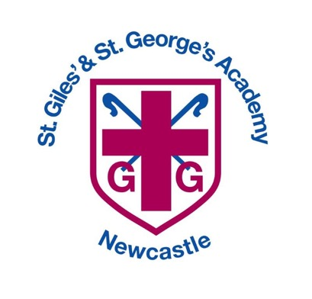

Pupil Premium


Pupil Premium
Intent, Implementation and Impact

Our community is inspired by our Christian values to enable all to flourish in mind, body, heart and spirit.
INTENT
Our Christian vision — “Our community is inspired by our Christian values to enable all to flourish in mind, body, heart and spirit” (Psalm 40:2) — and Three Spires Trust’s For Everyone inclusion framework come together to make inclusion the organising principle of life at St Giles’ & St George’s. We believe every pupil is welcomed, known and supported to thrive: spiritually, academically, socially and physically.
Key commitments
- Safety and belonging first: pupils learn best when they feel safe, known and included. Our warm, caring culture and specialist provision (The Orchard) give pupils a firm place to stand.
- High-quality, adaptive teaching: every classroom is expected to deliver an ambitious, well-sequenced curriculum that is adapted so pupils with SEND, identified needs, EAL or disadvantage can build knowledge reliably.
- Early identification and timely support: we prioritise early assessment, evidence-informed interventions and close partnership with families and external agencies so fewer pupils require costly statutory provisions.
- Participation and aspiration for all: barriers to engagement are removed so pupils access enrichment, leadership and wider opportunities that prepare them for future success.
- Shared accountability and local responsiveness: the trust-wide For Everyone framework sets our principles; the academy’s annual Inclusion Strategy translates them into the specific barriers, funded activities and measurable outcomes for our community.

Why this matters here
- With high proportions of pupils eligible for disadvantaged funding (DA 34%), inclusion is not an add-on — it is essential to securing good outcomes for the majority of our cohort.
- Our current school improvement priorities (adaptive teaching, inclusive provision, attendance, SIAMS, middle leader development) flow directly from this combined vision and strategy.
What success looks like (headline indicators)
- Increased proportion of pupils meeting age-related expectations across the curriculum, especially in foundation subjects where small steps are being clarified.
- Stronger, consistent practice across classrooms evidenced in termly learning walks and routine use of adaptive strategies.
In short: inspired by our Christian faith and guided by the Trust’s For Everyone framework, St Giles’ & St George’s places inclusion at the heart of everything we do — ensuring every pupil is safe, belongs, receives adaptive teaching and has their needs met so they can flourish now and in the future.
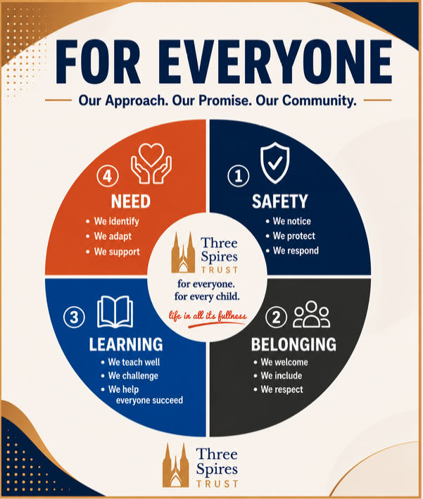
School Overview

Our school currently has 378 pupils on roll, with 41% eligible for Pupil Premium funding. This reflects our diverse community and our commitment to providing every child—regardless of background—with the support and opportunities they need to thrive. The breakdown of year group is shown below:

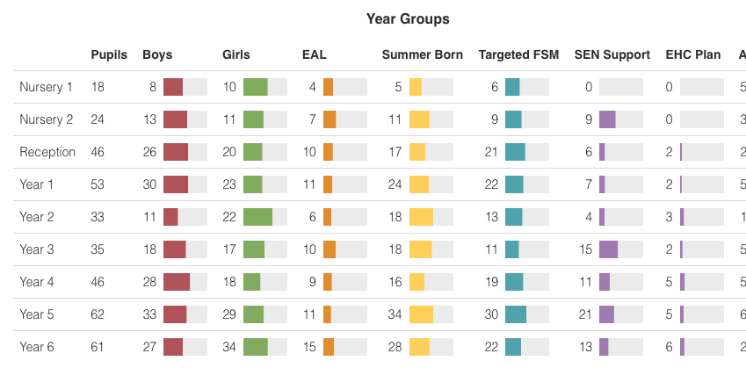

IMPLEMENTATION

At St Giles’ and St George’s, we offer a range of targeted provisions to support our Pupil Premium children in achieving their full potential. These include academic interventions, pastoral support, and enrichment opportunities designed to meet individual needs. Through personalised teaching, small-group work, mentoring, and access to wider experiences, we aim to remove barriers to learning and ensure every child feels valued, confident, and able to succeed.
We provide the following provisions and continuously review them to ensure that all pupils have access to the most effective resources and support.
Attendance | Pastoral | Healthy Body & Mind | Academic
- Waves of provision  - Support first approach  - Encouraging Arbor email messages and Dojo messages  - Teacher to parent meetings and support  - Pupil voice  - Attendance and punctuality clinics.  - Home visits if necessary.  - Designated Attendance Champion and Team  - Attendance Ambassadors-PP  - Rewards for attendance – family and children.  - Building firm and strong relationships with families  - Attendance action plans and supportive measures.  - Free full time nursery.  - Bespoke transition plans  - Free access to breakfast clubs/ wraparound care.  - Daily welcome from leaders and ambassadors  - Meet and greet with key adult  - Uniform washed, replaced, provided if needed.  - Parents evening reminders and options for attendance – virtual, telephone call, face to face.  - Pastoral Support available at all times.  - Clothing/ Food/ Hygiene giveaways  - Bespoke transition plans in all stages and individually  - Magic Breakfast  - Pupil leadership- incentives | - Additional transition  - Pastoral plans for children  - ELSA Therapy  - Providing uniform and school supplies  - Referrals and signposting to external services  - Funding for all trips, clubs and before/after school  - Enrichment opportunities  - Sensory circuits  - Access to sensory room  - Pastoral support unit access  - Individual whole school roles to boost self esteem  - Wellbeing club at lunchtime  - Forest group enrichment activities  - Additional transition-Y6, social stories,  - Pastoral Support available to message on Dojo.  - A range of pastoral interventions can be accessed.  - Animal therapy though the school dog  - School experiences linked to the curriculum.  - Providing uniform and school supplies.  - Invites to Wraparound care  - Free daily fruit and toast/ bagels/crumpets  - Referrals and signposting to outside agencies. YMCA, YOT, Catch 22, Police, New Era. MHST, Changes, Staywell  - Positive relationships with parents – Alice Charity, play and stay sessions, volunteers in school, workshops, training events, parental engagement and invitation  - Financial support – Food bank vouchers, Voucher schemes, outside agencies.  - Forest Schools. | - School foodbank  - Food Vouchers  - Parent workshops  - School nurse referrals  - Free school meals  - Breakfast provisions  - After school sports clubs  - Budgeting support for families  - Medical care plans  - Invites to sports camps in holidays  - Christmas gifts  - Holidays Cubs for PP children  - School nurse referrals.  - Social referrals  - Early language screening and intervention  - Free school meals.  - After school clubs – personal invites.  - Budgeting support for families.  - Medical care plans.  - Invites to wellbeing training/ workshops.  - Open door policy.  - Outdoor provision and forest schools.  - Music and Performance  - Wellbeing/MHST/ Time to Talk/ Mind Up  - Access to hygiene and sanitary products.  - Sessions with ASM, clubs and PE lessons.  - Links with Stoke City Football Club – experience days,  - Slow Cooker project, Food parcels, Christmas presents etc Alice Charity  - Uniform collection and sale  - Invites to Fitzy festivals and bespoke PE sessions  - Access to sporting competitions, events and performance and support with transport if required  - Links with external providers | - Wide range of before and after school clubs  - RADY approach to quality first teaching  - In school interventions  - Aspirational Targets  - Scaffolding for aspiration  - Access to technology  - Enrichment opportunities with funding.  - School funded music lessons  - Breakfast and books  - Home access to phonics & time table subscriptions  - Staff are clear who PP children are and termly meeting held with PP lead.  - Parenting workshops.  - Individual daily reading as needed.  - Library  - Pre and post teach/ Intervention  - Scaffolding for aspiration  - Access to technology- AI Next Gen  - Targeted clubs  - Home access to TTRS, SATs Companion etc  - Flexible grouping and adaptive teaching  - Bespoke speech and language programmes  - Support from outside specialists  - Bespoke CPD for staff  - Curriculum Teams of staff  - Links to hubs to share best practise  - Links with other schools  - Aspirations and high expectations

IMPACT

We will monitor and evaluate the achievement of our Pupil Premium pupils each term, comparing their progress with that of all other pupils through a range of methods. This will include:
- analysis of assessment data
- attendance
- behaviour records
- pupil interviews
- other relevant monitoring activities.

This ensures we provide the right support for every child and continually refine our approach to close attainment gaps

