

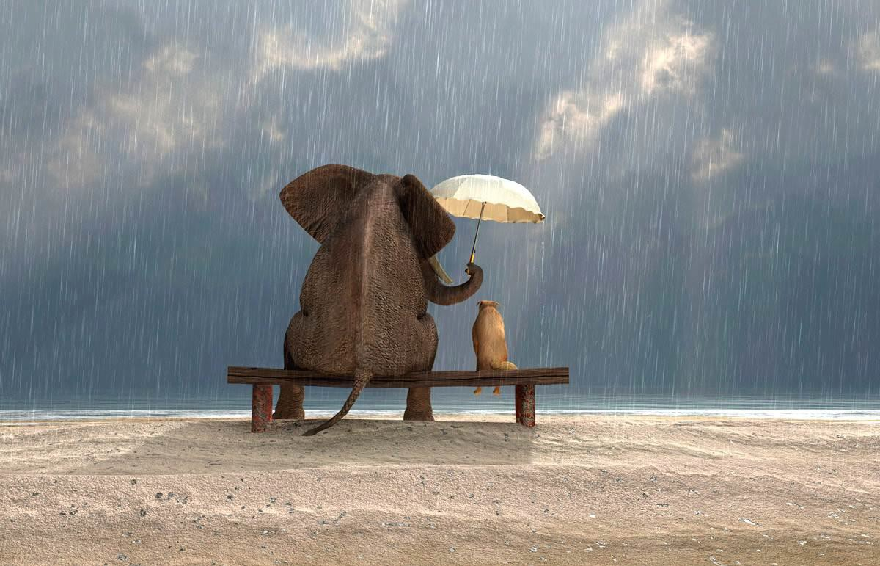

PSHE Curriculum

PSHE Intent, Implementation and Impact

Our Community is inspired by our Christian values to enable all to flourish in mind, body, heart and spirit.
He set my feet upon a rock and gave me a firm place to stand. (Psalm 40 V.2)
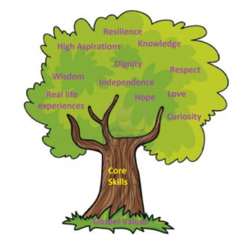
Intent
All areas of our curriculum are underpinned by our Gospel values and we ensure that our curriculum makes links to these values. At the heart of each subject is a set of core skills which form a subject learning journey, this journey is built from EYFS through to year 6 and the skills are progressive as you move through the school. Knowledge is communicated to ensure coverage of the National curriculum and it is through this knowledge that children apply their skills.
Children at St Giles’ and St George’s leave with a secure knowledge of both the academic knowledge and skills needed for the next stage of their education. They will have developed a clear set of Christian and moral values which they can apply in all areas of their lives and will have taken part in real-life experiences, which will have raised their aspirations and given them a thirst for wisdom and knowledge.
The intention of the St Giles’ and St George’s Personal, Social and Health Education (PSHE) learning journey is first and foremost to maximise the outcomes for every child by equipping them with the knowledge of how to make healthy choices, become independent and responsible members of society and to have the confidence to give their opinion on many moral, social and cultural issues that they may come across during their life. As a school, we strive to provide our children with many opportunities for them to learn about human rights and responsibilities, to appreciate what it means to be a member of our diverse society and to make a positive contribution to school life and the wider community.
Implementation
St Giles’ and St George’s PSHE Learning journey combines the aspects of Personal, Social and Health education. Throughout the journey from nursery to Year 6, we follow a spiral curriculum to ensure progression of knowledge and skills on 6 key topics which are each taught for a half-term. At the start of each half-term, an assembly will introduce the theme of each topic for the school.
The PSHE units focus on 6 key areas
• Being Me
• Celebrating Differences
• Dreams and Goals
• Healthy Me
• Relationships
• Changing Me
PSHE is taught for 1 hour each week, each new unit of learning is introduced through a mind map, or something similar, to EXPLORE the current knowledge and understanding that the children have of the topic. At this point, pupils are also asked what they would like to learn about within the broader topic. Children are then TAUGHT the key knowledge which will be shared during the unit in the form of a knowledge organiser. The knowledge organiser will be shared at the start and end of each lesson with key knowledge for each lesson highlighted. Following this, the Class Charter should also be shared and discussed with the children. During the lesson, children will have the opportunity to PRACTISE and APPLY this knowledge and skills. Activities are differentiated where appropriate and assessment and feedback will focus on misconceptions and next steps for learning. At the end of each unit of learning, children will REVIEW their initial mind map with new knowledge and understanding, this will feed into future planning. This lesson Journey is illustrated below.
In PSHE, work is recorded through the use of class floorbooks. This may be in the form of photographs, quotes from children, drawings, written work and show differentiation where appropriate.
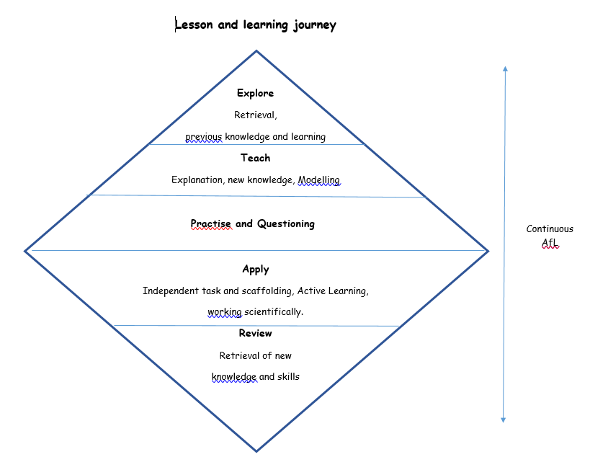

EYFS
As part of Development Matters (2021), PSHE is taught in relation to the strand Personal, Social and emotional development. Children in EYFS have a PSHE lesson once per week, following the same units as the rest of the school. Lessons follow the whole school format where children take part in the Explore – Teach – Practise – Apply – Review cycle illustrated here. Children will also have the opportunity to practise and develop their PSED skills in the child-initiated continuous provision.
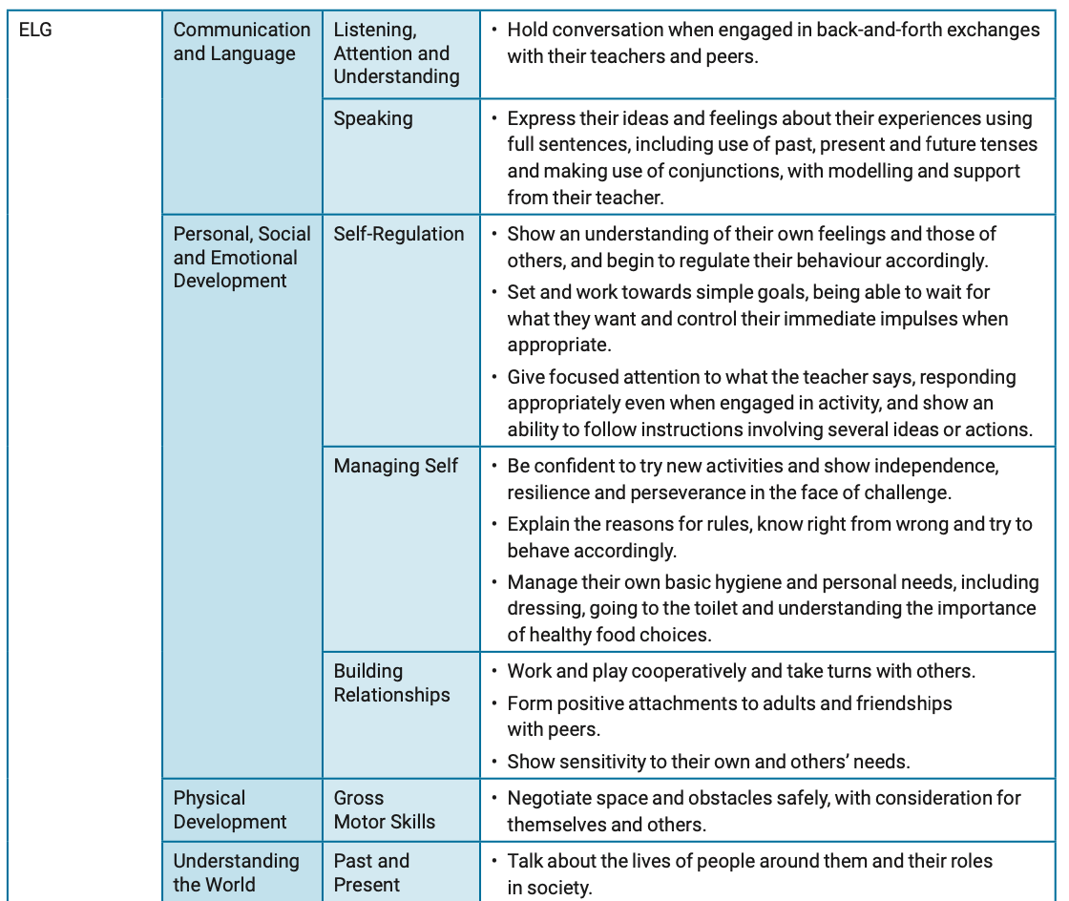
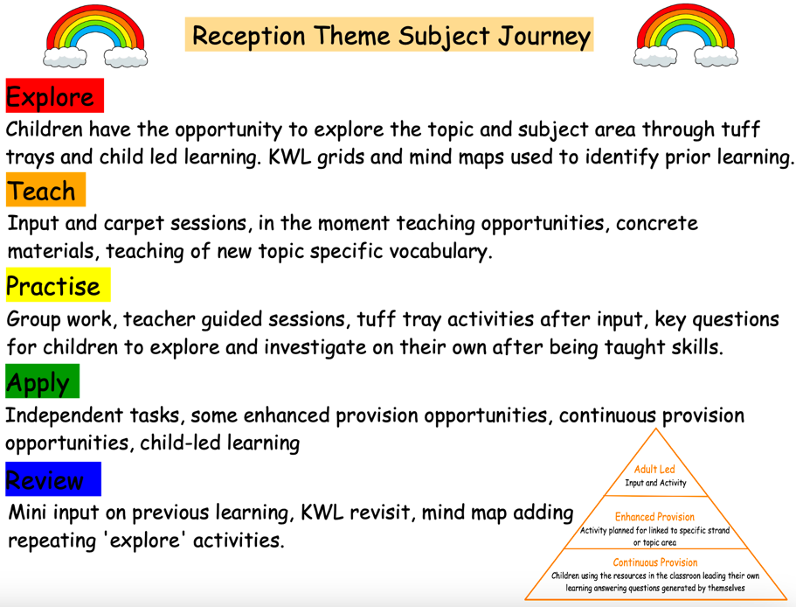

PSHE is taught as part of the Personal, Social and Emotional Development area of the EYFS learning and development. Children in Reception have a PSHE lesson once per week, following the same units as the rest of the school. Where appropriate, lessons and unit will take the same form as the rest of the school: explore, teach, practise, apply and review. Children will also have the opportunity to practise and develop their PSED skills in the enhanced and child-initiated continuous provision. Evidence of PSHE lessons and other supporting evidence can be found on Evidence Me linked to the appropriate statement s and ELG.

Impact
In addition to the outcomes shown on our curriculum tree, the specific personal, social and health impact of the St Giles’ and St George’s PSHE Learning Journey is that children will have the ability to develop:

• Happy and positive relationships
• Empathy and compassion
• The confidence to make the most of their abilities
• Value and respect of diversity
• Respect for others’ rights to their own values and beliefs
• Evaluation (and appropriate challenge) of the opinions and arguments of others
• Leadership and presentation skills
• Strategies for managing influence
• Enterprise skills and attributes
• Skills for employability (aspiration, communication, creativity, goal setting)
• Taking positive risks
Formative assessment takes part in each lesson and misconception and next steps of the focus for feedback. In PSHE, there is no summative assessment.

RSE Intent, Implementation and Impact

Our Community is inspired by our Christian values to enable all to flourish in mind, body, heart and spirit.
He set my feet upon a rock and gave me a firm place to stand. (Psalm 40 V.2)
Intent
All areas of our curriculum are underpinned by our Gospel values and we ensure that our curriculum makes links to these values. At the heart of each subject, is a set of core skills which form a subject learning journey, this journey is built from EYFS through to year 6 and the skills are progressive as you move through the school. Knowledge is communicated to ensure coverage of the National curriculum and it is through this knowledge that children apply their skills.
Children at St Giles’ and St George’s leave with a secure knowledge of both the academic knowledge and skills needed for the next stage of their education. They will have developed a clear set Christian and moral values which they can apply in all areas of their lives and will have taken part in real-life experiences, which will have raised their aspirations and given them a thirst for wisdom and knowledge.
The intention of the St Giles’ and St George’s Relationships and Sex Education (RSE) learning journey is for children to develop positive relationships, that are fundamental to our ethos and being a happy, safe and caring school, prepare for the wider world beyond primary school: a world in which they can keep themselves safe and healthy and thrive with the support of the positive relationships they forge with those around them. RSE has a key part to play in the personal, social, moral and spiritual development of young people.
Implementation
St Giles’ and St George’s RSE Learning journey combines the aspects of statutory relationship education and non-statutory sex education in a spiral based curriculum. RSE is taught as explicit lessons through the PSHE and science curriculums but it is also embedded in other areas of the curriculum and day to day life of the school. In Y1-Y6 PSHE, RSE is specifically covered in the PSHE units ‘Relationships’ and ‘Changing Me’ and in science ‘Animals Including Humans’ and ‘Living Things and Their Habitats’. For children in Nursery and Reception, this unit will follow the guidance of the EYFS PSED prime area.
RSE is taught for 1 hour each week in the final summer half-term of each year. For identified lessons linked to puberty and human reproduction, children in mixed classes will be taught their correct age unit lessons. In KS2 classes, children will be taught separately as boys and girls, due to the sensitive content and so that the staff member is able to spend more time on specific topics, e.g. menstruation for girls. In these identified lessons, there will also be 2 members of staff in each room. This is so that one member of staff is able to teach the lesson and the second member of staff is able to facilitate and answer questions where they arise.

As with all PSHE units, each new unit of learning is introduced through a ‘Know, Want, Learnt’ KWL grid to EXPLORE the current knowledge and understanding of the topic. At this point, pupils are also asked what they would like to learn about within the broader topic. Children are then TAUGHT the key knowledge which will be shared during the unit in the form of a knowledge organiser. The knowledge organiser will be shared at the start and end of each lesson with key knowledge for each lesson highlighted. Following this, the Class Charter should also be shared and discussed with the children. During the lesson, children will have the opportunity to PRACTISE and APPLY this knowledge and skills. Activities are differentiated where appropriate and assessment and feedback will focus on misconceptions and next steps for learning. At the end of each unit of learning, children REVIEW their initial KWL grid with new knowledge and understanding in the Learnt column, this will feed into future planning.
In PSHE, work is recorded through the use of class floorbooks. This may be in the form of photographs, quotes from children, drawings, written work and differentiation where appropriate.

Impact
In addition to the outcomes shown on our curriculum tree, the specific personal, social and health impact of the St Giles’ and St George’s RSE Learning Journey is that children will:
• Demonstrate confidence and awareness about sex and relationships in an independent and safe way
• Have a good understanding about safety and risks in relationships
• Be prepared for the physical and emotional changes they undergo during puberty
• Prepare learners for the challenges, opportunities, and responsibilities of adult life

We continuously assess the implementation and impact of our RSE curriculum in order to achieve the highest outcomes possible across all year groups and ensure we provide the support that is necessary for all children to have a good understanding of the complexities of relationships and sexual matters and a secure knowledge and skills base to navigate their way through these, now and in the future. This is carried out through staff voice and training, pupil voice, parent consultations of RSE materials and planning scrutinies by the RSE lead. Through our RSE curriculum, we believe we can enhance children’s education and help them to become confident individuals who have positive body awareness, an in-depth knowledge of how to keep themselves safe and healthy and who will, through respect, tolerance and understanding, forge and maintain positive relationships with a diverse range of family and friendship groups.

Formative assessment takes part in each lesson and misconception and next steps of the focus for feedback. In PSHE, there is no summative assessment.

Adaptive Teaching

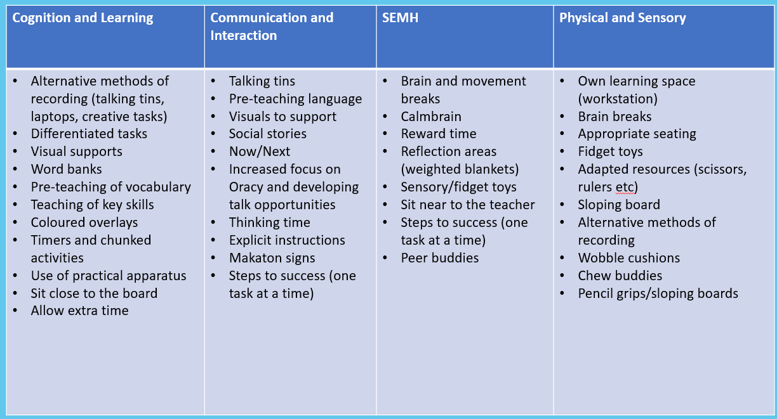

Gospel Values

EYFS  Attentive and Discerning  To be considerate in the choices we make and how they could affect others.  Curious and Active  To be curious about the way our bodies change and to actively look after ourselves.  Loving and Compassionate  To show kindness to our friends.  Grateful and Generous  To be grateful for being a special human being that is unique.  Intentional and Prophetic  To plan to live a healthy life by eating the right foods and exercising.  Faith- filled and Hopeful  To be hopeful for the new year and what we can do. | KS1  Loving and Compassionate  To be kind, compassionate and loving to our friends and family.  Curious and Active  To be curious about the way our bodies change and to actively look after ourselves.  Intentional and Prophetic  To plan to live a healthy life by eating the right foods and exercising.  Learned and Wise  Faith- filled and Hopeful  To be hopeful for the new year and what we can achieve.  Grateful and Generous  To be grateful to God for being a special human being that is unique.  Attentive and Discerning  To be considerate in the choices we make and how they could affect others.
LKS2  Loving and Compassionate  To be kind, compassionate and loving to our friends and family.  Curious and Active  To be curious about the way our bodies change and to actively look after ourselves.  Intentional and Prophetic  To plan to live a healthy life by eating the right foods and exercising.  Learned and Wise  Faith- filled and Hopeful  To be hopeful for the new year and what we can achieve.  Grateful and Generous  To be grateful to God for being a special human being that is unique.  Attentive and Discerning  To be considerate in the choices we make and how they could affect others. | UKS2  Loving and Compassionate  To be kind, compassionate and loving to our friends and family.  Curious and Active  To be curious about the way our bodies change and to actively look after ourselves.  Intentional and Prophetic  To plan to live a healthy life by eating the right foods and exercising.  Learned and Wise  Faith- filled and Hopeful  To be hopeful for the new year and what we can achieve.  Grateful and Generous  To be grateful to God for being a special human being that is unique.  Attentive and Discerning  To be considerate in the choices we make and how they could affect others.

PSHE Overview

 | Autumn Term |  | Spring Term |  | Summer Term
 | Autumn 1 | Autumn 2 | Spring 1 | Spring 2 | Summer 1 | Summer 2
 | Being Me In My World | Celebrating Difference | Dreams and Goals | Healthy Me | Relationships | Changing Me
EYFS | What is your favourite season? Why?  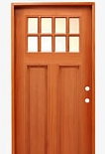 | Why are people different? | What is important to me?   | What do you do with your time after school? | What makes a good friend?  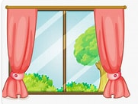 | Is it ok to be sad?
KS1 A | Do colours have different moods? What gives them these moods? | Do I treat other people in the same way? | What excites me about the future? |  | Why do we fight and argue?  NSPCC PANTS | Who am I?
KS1 B | Is it OK to sometime give up? | How can I demonstrate compassion? | If I try to succeed and fail, what have I learned? | Why do people bully others?  NSPCC Stay Safe Speak Out Workshops | Should I treat my friends differently from others? | Repeat NSPCC PANTS if needed.
LKS2 B | What responsibilities do I have for others? | What does it mean that ‘beauty is in the eye of the beholder’?  Maccas Project – Mental health Workshops | What type of person do I want to be? | What type of person do I want to be? | What difference does being loved make?
LKS2 A | What rights do I have? | Will we ever live in a world without fighting?  Maccas Project – Mental health Workshops  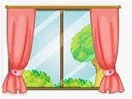 | How can we care for someone that we have never met? | What do I deserve in life? |  | Who should I look up to?
UKS2 A | Why isn’t life always fair? | Where does your identity come from?   | Will we ever succeed?  NSPCC Stay Safe Speak Out Workshops |  | Can you love something that is ugly?  GLOW (Relationships without Fear) | Is it better to please oneself, or others first?
UKS2 B | Is my understanding of self a selfish concept? | Why do people have to suffer? | Are my beliefs important?  NSPCC Stay Safe Speak Out Workshops | Does having more mean being happier? | Is there such a. thing as a bad person?

Spirituality Questions
Enrichment Opportunities

PSHE Whole School
PSHE Whole School Knowledge and skills Overview

Being Me in My World
 | EYFS | KS1 | LKS2 | UKS2
Knowledge | Feeling special and safe Being part of a class  Rights and responsibilities Rewards and feeling proud Consequences  Owning the Learning Charter | Setting personal goals  Self-identity and worth Positivity in challenges Rules, rights and responsibilities  Rewards and consequences  Responsible choices  Seeing things from others’ perspectives | Planning the forthcoming year  Being a citizen  Rights and responsibilities Rewards and consequences  How behaviour affects groups  Democracy,  having a voice, participating | Personal identity  What influences personal identity  Identify personal strengths  How do others see me? Group identity  My growing sense of personal identity and independence  Online and global identity Expectations
Skills | Identify feelings associated with belonging  Skills to play co-operatively with others  Be able to consider others’ feelings | Know how to make their class a safe and fair place  Show good listening skills  Be able to work co-operatively | Identify the feelings associated with being included or excluded  Be able to take on a role in a group discussion / task and contribute to the overall outcome  Know how to regulate my emotions | Know own wants and needs  Be able to compare their life with the lives of those less fortunate  Demonstrate empathy and understanding towards others  Can demonstrate attributes of a positive role-model

Celebrating Difference
 | EYFS | KS1 | LKS2 | UKS2
Knowledge | Similarities and differences  Understanding bullying and knowing how to deal with it  Making new friends Celebrating the differences in everyone | Families and their differences  Family conflict and how to manage it (child-centred) Witnessing bullying and how to solve it  Recognising how words can be hurtful  Giving and receiving compliments | Cultural differences and how they can cause conflict  Racism Rumours and name-calling  Types of bullying  Material wealth and happiness  Enjoying and respecting other cultures | Assertiveness  Prejudice and discrimination  My values and those of others  Challenging stereotypes Discrimination in school How prejudice and discrimination fuels bullying  Being inclusive
Skills | Recognise emotions when they or someone else is upset, frightened or angry  Identify and use skills to make a friend  Identify some ways they can be different and the same as others  Identify and use skills to stand up for themselves | Explain how being bullied can make someone feel  Know how to stand up for themselves when they need to  Understand that everyone’s differences make them special and unique | Be comfortable with the way they look  Try to accept people for who they are  Be non-judgemental about others who are different | Empathise with people who are different and be aware of my own feelings towards them  Identify feelings associated with being excluded  Be able to recognise when someone is exerting power negatively in a relationship  Be able to vocalise their thoughts and feelings about prejudice and discrimination and why it happens

Dreams and Goals
 | EYFS | KS1 | LKS2 | UKS2
Knowledge | Setting goals  Identifying successes and achievements  Learning styles  Working well and celebrating achievement with a partner  Tackling new challenges Identifying and overcoming obstacles Feelings of success | Difficult challenges and achieving success  Dreams and ambitions New challenges  Motivation and enthusiasm  Recognising and trying to overcome obstacles Evaluating learning processes  Managing feelings  Simple budgeting | Future dreams  The importance of money Jobs and careers  Dream job and how to get there  Goals in different cultures Supporting others (charity)  Motivation | What are my dreams and goals?  Steps to success  Coping when things don’t go to plan  Rewarding my dreams Intrinsic and extrinsic motivation  Keeping my dreams alive How dreams and goals change in response to life
Skills | Understand that challenges can be difficult  Resilience  Recognise some of the feelings linked to perseverance  Recognise how kind words can encourage people | Recognise how working with others can be helpful  Be able to work effectively with a partner  Be able to choose a partner with whom they work well  Be able to work as part of a group | Have a positive attitude  Can identify the feeling of disappointment  Be able to cope with disappointment  Can identify what resilience is | Understand why it is important to stretch the boundaries of their current learning  Be able to give praise and compliments to other people when they recognise that person’s achievements  Empathise with people who are suffering or living in difficult situations

Healthy Me
 | EYFS | KS1 | LKS2 | UKS2
Knowledge | Keeping myself healthy Healthier lifestyle choices Keeping clean  Being safe Medicine safety/safety with household items  Road safety  Linking health and happiness | Exercise Fitness Challenges Food labelling and healthy swaps  Attitudes towards drugs Keeping safe and why it’s important online and off line scenarios  Respect for myself and others  Healthy and safe choices | Smoking, including vaping Alcohol  Alcohol and anti-social behaviour  Emergency aid  Body image  Relationships with food Healthy choices  Motivation and behaviour | Healthy choices about my emotional health  Managing stress  Managing my choices around substances Managing my nutritional choices  Medicines and immunisation  Healthy choices about physical activity and rest/sleep
Skills | Can explain what they need to do to stay healthy  Recognise how exercise makes them feel  Can give examples of healthy food  Can explain what to do if a stranger approaches the. | Feel positive about caring for their bodies and keeping it healthy  Have a healthy relationship with food  Desire to make healthy lifestyle choices | Can identify the feelings that they have about their friends and different friendship groups  Recognise negative feelings in peer pressure situations  Can identify the feelings of anxiety and fear associated with peer pressure  Can tap into their inner strength and know-how to be assertive | Are motivated to care for their own physical and emotional health  Suggest strategies someone could use to avoid being pressured  Can use different strategies to manage stress and pressure

Relationships
 | EYFS | KS1 | LKS2 | UKS2
Knowledge | Belonging to a family  Making friends/being a good friend. Physical contact preferences. People who help us Qualities as a friend and person. Self-acknowledgement Being a good friend to myself  Celebrating special relationships | Family roles and responsibilities  Friendship and negotiation Keeping safe online and who to go to for help  Being a global citizen. Being aware of how my choices affect others Awareness of how other children have different lives  Expressing appreciation for family and friends | Self-recognition and self-worth  Building self-esteem  Safer online communities Rights and responsibilities online  Online gaming and gambling  Reducing screen time Dangers of online grooming  SMART internet safety rules | My changing web of friendships  Support I need now and in the future  Developing positive relationships  What external factors affect relationships, e.g. media influences? Assertiveness in relationships  The changing role of families
Skills | Can identify what jobs they do in their family and those carried out by parents/carers and siblings  Can suggest ways to make a friend or help someone who is lonely | Can recognise and talk about the types of physical contact that is acceptable or unacceptable  Can identify the negative feelings associated with keeping a worry secret  Can identify who they trust in their own relationships | Can identify the feelings and emotions that accompany loss  Can suggest strategies for managing loss  Can suggest ways to manage relationship changes including how to negotiate | Recognise that people can get problems with their mental health and that it is nothing to be ashamed of.  Can resist pressure to do something online that might hurt themselves or others  Can take responsibility for their own safety and well-being

Changing Me
 | EYFS | KS1 | LKS2 | UKS2
Knowledge | Life cycles – animal and human  Changes in me  Changes since being a baby  Differences between female and male bodies (correct terminology) Linking growing and learning  Coping with change. Transition | How babies grow Understanding a baby’s needs  Outside body changes Inside body changes Family stereotypes Challenging my ideas Preparing for transition | Self- and body image Influence of online and media on body image Puberty for girls  Puberty for boys Conception (including IVF) Growing responsibility Coping with change Preparing for transition | My changing body and feelings  What is self-image?  Coping during times of change  My changing ways of thinking  Managing my changes in mood  Moving forwards into my next year of education
Skills | Recognise that changing class can elicit happy and/or sad emotions  Can say how they feel about changing class/ growing up  Can identify how they have changed from a baby | Can say who they would go to for help if worried or scared  Can say what types of touch they find comfortable/uncomfortable  Be able to confidently ask someone to stop if they are being hurt or frightened | Can appreciate their own uniqueness and that of others  Can express any concerns they have about puberty  Have strategies for managing the emotions relating to change | Recognise ways they can develop their own self-esteem  Can express how they feel about the changes that will happen to them during puberty  Understand that mutual respect is essential in a boyfriend/girlfriend relationship and that they shouldn’t feel pressured into doing something that they don’t want to

National Curriculum Links
(Based on the Scheme of Learning from the PSHE Association)

 | KS1 | LKS2 / UKS2
Being Me in my World | L1. about what rules are, why they are needed, and why different rules are needed for different situations  L2. how people and other living things have different needs; about the responsibilities of caring for them  L3. about things they can do to help look after their environment  L4. about the different groups they belong to  L5. about the different roles and responsibilities people have in their community L6. to recognise the ways they are the same as, and different to, other people | L1. to recognise reasons for rules and laws; consequences of not adhering to rules and laws  L2. to recognise there are human rights, that are there to protect everyone L3. about the relationship between rights and responsibilities  L4. the importance of having compassion towards others; shared responsibilities we all have for caring for other people and living things; how to show care and concern for others  L5. ways of carrying out shared responsibilities for protecting the environment in school and at home; how everyday choices can affect the environment (e.g. reducing, reusing, recycling; food choices)  L6. about the different groups that make up their community; what living in a community means  L7. to value the different contributions that people and groups make to the community  L8. about diversity: what it means; the benefits of living in a diverse community; about valuing diversity within communities  L9. about stereotypes; how they can negatively influence behaviours and attitudes towards others; strategies for challenging stereotypes  L10. about prejudice; how to recognise behaviours/actions which discriminate against others; ways of responding to it if witnessed or experienced
Dreams and Goals | L14. that everyone has different strengths  L15. that jobs help people to earn money to pay for things  L16. different jobs that people they know or people who work in the community do  L17. about some of the strengths and interests someone might need to do different jobs | L25. to recognise positive things about themselves and their achievements; set goals to help achieve personal outcomes  L26. that there is a broad range of different jobs/careers that people can have; that people often have more than one career/type of job during their life  L27. about stereotypes in the workplace and that a person’s career aspirations should not be limited by them  L28. about what might influence people’s decisions about a job or career (e.g. personal interests and values, family connections to certain trades or businesses, strengths and qualities, ways in which stereotypical assumptions can deter people from aspiring to certain jobs)  L29. that some jobs are paid more than others and money is one factor which may influence a person’s job or career choice; that people may choose to do voluntary work which is unpaid  L30. about some of the skills that will help them in their future careers e.g. teamwork, communication and negotiation  L31. to identify the kind of job that they might like to do when they are older  L32. to recognise a variety of routes into careers (e.g. college, apprenticeship, university)
Healthy Me | H1. about what keeping healthy means; different ways to keep healthy  H2. about foods that support good health and the risks of eating too much sugar  H3. about how physical activity helps us to stay healthy; and ways to be physically active everyday  H4. about why sleep is important and different ways to rest and relax H5. simple hygiene routines that can stop germs from spreading  H6. that medicines (including vaccinations and immunisations and those that support allergic reactions) can help people to stay healthy .  H7. about dental care and visiting the dentist; how to brush teeth correctly; food and drink that support dental health H8. how to keep safe in the sun and protect skin from sun damage  H9. about different ways to learn and play; recognising the importance of knowing when to take a break from time online or TV  H10. about the people who help us to stay physically healthy. | H1. how to make informed decisions about health  H2. about the elements of a balanced, healthy lifestyle  H3. about choices that support a healthy lifestyle, and recognise what might influence these  H4. how to recognise that habits can have both positive and negative effects on a healthy lifestyle  H5. about what good physical health means; how to recognise early signs of physical illness  H6. about what constitutes a healthy diet; how to plan healthy meals; benefits to health and wellbeing of eating nutritionally rich foods; risks associated with not eating a healthy diet including obesity and tooth decay.  H7. how regular (daily/weekly) exercise benefits mental and physical health (e.g. walking or cycling to school, daily active mile); recognise opportunities to be physically active and some of the risks associated with an inactive lifestyle  H8. about how sleep contributes to a healthy lifestyle; routines that support good quality sleep; the effects of lack of sleep on the body, feelings, behaviour and ability to learn  H9. that bacteria and viruses can affect health; how everyday hygiene routines can limit the spread of infection; the wider importance of personal hygiene and how to maintain it  H10. how medicines, when used responsibly, contribute to health; that some diseases can be prevented by vaccinations and immunisations; how allergies can be managed
Relationships | R1. about the roles different people (e.g. acquaintances, friends and relatives) play in our lives  R2. to identify the people who love and care for them and what they do to help them feel cared for  R3. about different types of families including those that may be different to their own  R4. to identify common features of family life  R5. that it is important to tell someone (such as their teacher) if something about their family makes them unhappy or worried  R6. about how people make friends and what makes a good friendship  R7. about how to recognise when they or someone else feels lonely and what to  do  R8. simple strategies to resolve arguments between friends positively R9. how to ask for help if a friendship is making them feel unhappy  R10. that bodies and feelings can be hurt by words and actions; that people can say hurtful things online  R11. about how people may feel if they experience hurtful behaviour or bullying  R12. that hurtful behaviour (offline and online) including teasing, name-calling, bullying and deliberately excluding others is not acceptable; how to report bullying; the importance of telling a trusted adult  R13. to recognise that some things are private and the importance of respecting privacy; that parts of their body covered by underwear are private  R14. that sometimes people may behave differently online, including by pretending to be someone they are not  R15. how to respond safely to adults they don’t know  R16. about how to respond if physical contact makes them feel uncomfortable or  unsafe  R17. about knowing there are situations when they should ask for permission and also when their permission should be sought  R18. about the importance of not keeping adults’ secrets (only happy surprises that others will find out about eventually)  R19. basic techniques for resisting pressure to do something they don’t want to do and which may make them unsafe  R20. what to do if they feel unsafe or worried for themselves or others; who to ask for help and vocabulary to use when asking for help; importance of keeping trying until they are heard | R1. to recognise that there are different types of relationships (e.g. friendships, family relationships, romantic relationships, online relationships)  R2. that people may be attracted to someone emotionally, romantically and sexually; that people may be attracted to someone of the same sex or different sex to them; that gender identity and sexual orientation are different  R3. about marriage and civil partnership as a legal declaration of commitment made by two adults who love and care for each other, which is intended to be lifelong  R4. that forcing anyone to marry against their will is a crime; that help and support is available to people who are worried about this for themselves or others  R5. that people who love and care for each other can be in a committed relationship (e.g. marriage), living together, but may also live apart  R6. that a feature of positive family life is caring relationships; about the different ways in which people care for one another  R7. to recognise and respect that there are different types of family structure (including single parents, same-sex parents, step-parents, blended families, foster parents); that families of all types can give family members love, security and stability  R8. to recognise other shared characteristics of healthy family life, including commitment, care, spending time together; being there for each other in times of difficulty  R9. how to recognise if family relationships are making them feel unhappy or unsafe, and how to seek help or advice  R10. about the importance of friendships; strategies for building positive friendships; how positive friendships support wellbeing  R11. what constitutes a positive healthy friendship (e.g. mutual respect, trust, truthfulness, loyalty, kindness, generosity, sharing interests and experiences, support with problems and difficulties); that the same principles apply to online friendships as to face-to-face relationships  R12. to recognise what it means to ‘know someone online’ and how this differs from knowing someone face-to-face; risks of communicating online with others not known face-to-face  R13. the importance of seeking support if feeling lonely or excluded  R14. that healthy friendships make people feel included; recognise when others  may feel lonely or excluded; strategies for how to include them  R15. strategies for recognising and managing peer influence and a desire for peer approval in friendships; to recognise the effect of online actions on others  R16. how friendships can change over time, about making new friends and the benefits of having different types of friends  R17. that friendships have ups and downs; strategies to resolve disputes and reconcile differences positively and safely  R22. about privacy and personal boundaries; what is appropriate in friendships and wider relationships (including online);  R23. about why someone may behave differently online, including pretending to be someone they are not; strategies for recognising risks, harmful content and contact; how to report concerns  R24. how to respond safely and appropriately to adults they may encounter (in all contexts including online) whom they do not know  R25. recognise different types of physical contact; what is acceptable and unacceptable; strategies to respond to unwanted physical contact  R26. about seeking and giving permission (consent) in different situations  R27. about keeping something confidential or secret, when this should (e.g. a birthday surprise that others will find out about) or should not be agreed to, and when it is right to break a confidence or share a secret  R28. how to recognise pressure from others to do something unsafe or that makes them feel uncomfortable and strategies for managing this  R29. where to get advice and report concerns if worried about their own or someone else’s personal safety (including online)  R18. to recognise if a friendship (online or offline) is making them feel unsafe or uncomfortable; how to manage this and ask for support if necessary
Changing Me | H21. to recognise what makes them special  H22. to recognise the ways in which we are all unique  H23. to identify what they are good at, what they like and dislike  H24. how to manage when finding things difficult  H25. to name the main parts of the body including external genitalia (e.g. vulva, vagina, penis, testicles)  H26. about growing and changing from young to old and how people’s needs change  H27. about preparing to move to a new class/year group | H25. about personal identity; what contributes to who we are (e.g. ethnicity, family, gender, faith, culture, hobbies, likes/dislikes)  H26. that for some people gender identity does not correspond with their biological sex  H27. to recognise their individuality and personal qualities  H28. to identify personal strengths, skills, achievements and interests and how  these contribute to a sense of self-worth  H29. about how to manage setbacks/perceived failures, including how to re-frame unhelpful thinking  H30. to identify the external genitalia and internal reproductive organs in males and females and how the process of puberty relates to human reproduction  H31. about the physical and emotional changes that happen when approaching and during puberty (including menstruation, key facts about the menstrual cycle and menstrual wellbeing, erections and wet dreams)  H32. about how hygiene routines change during the time of puberty, the importance of keeping clean and how to maintain personal hygiene  H33. about the processes of reproduction and birth as part of the human life cycle; how babies are conceived and born (and that there are ways to prevent a baby being made); how babies need to be cared for1  H34. about where to get more information, help and advice about growing and changing, especially about puberty  H35. about the new opportunities and responsibilities that increasing independence may bring  H36. strategies to manage transitions between classes and key stages

Appendix 1: RSE Curriculum map

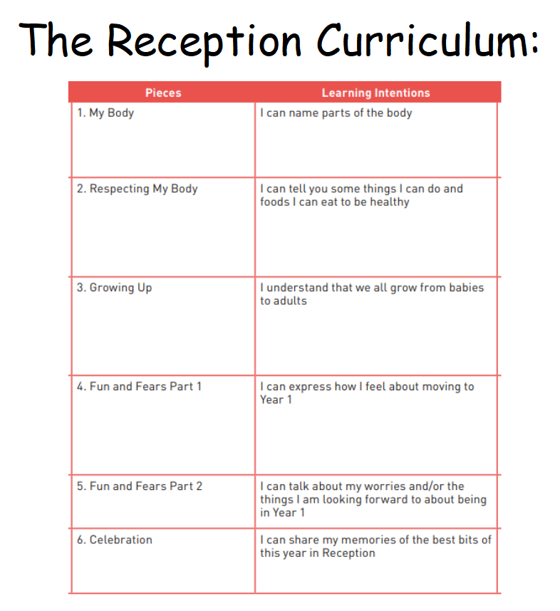
The grid below shows specific learning intentions for each year group. These specific 6 lessons are taught in the Summer term and look at change and coping with change in lots of contexts, so changes as we grow up and enter puberty are seen as one sort of change that we can all cope with. The map below highlights the statutory and non-statutory elements of this curriculum. Parents have the right to remove their child from the non- statutory elements of this curriculum only



