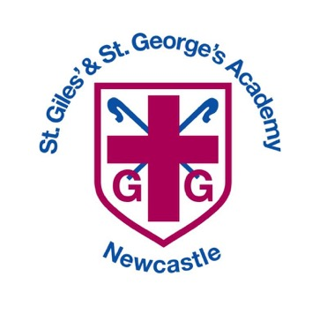

\

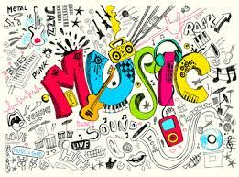
Music Curriculum



Music Intent, Implementation and Impact

Vision: Our community is inspired by our Christian Values to enable all to flourish in mind, body, heart and spirit.
Intent
All areas of our curriculum are underpinned by our Gospel values, and we ensure that our curriculum makes links to these values. At the heart of each subject is a set of core skills which form a subject learning journey, this journey is built from EYFS through to year 6 and the skills progress as you move through the school. Knowledge is communicated to ensure coverage of the National curriculum and it is through this knowledge that children apply their skills.
Children at St Giles’ and St George’s leave with a secure knowledge of both the academic knowledge and skills needed for the next stage of their education. They will have developed a clear set Christian and moral values which they can apply in all areas of their lives and will have taken part in real-life experiences which will have raised their aspirations and given them a thirst for wisdom and knowledge. Music is a powerful tool that can bring children together and develop their self-esteem and confidence. The intention of the St Giles’ and St George’s Music learning journey is to nurture this tool, so that children feel that they are musical and develop a life-long love of music.

We focus on developing the skills, knowledge and understanding that children need to become confident performers, composers and listeners. Our learning journey introduces children to real life musical experiences from around the world and across the generations.
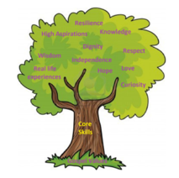

Implementation

St Giles’ and St George’s Music Learning Journey takes an holistic approach to music, the individual strands below are woven together to create an engaging and enriching learning experience.
- Listening and Evaluating
- Creating sounds
- Notation
- Improvising and composing
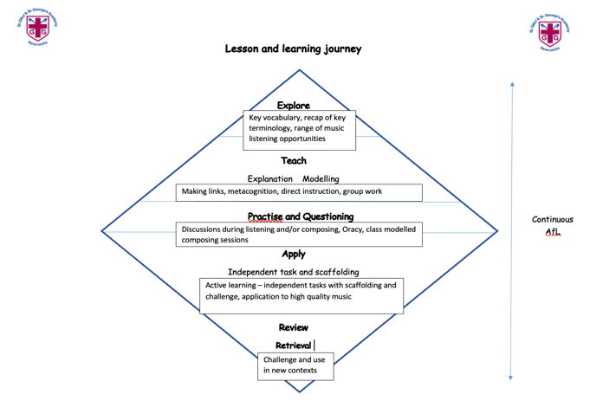
- Performing – Singing and Playing

Over the course of the journey children will be taught to sing fluently and expressively, play tuned and untuned instruments accurately and with control. They will learn to recognise and name pitch, duration, tempo, timbre, structure, texture and dynamics whilst using them in their own improvisations and compositions. A spiral curriculum model is followed where previous skills and knowledge are revisited and built upon.

Music is taught for 45 mins each week or 1hr 30 mins every two weeks depending on the unit and year group being taught. Each new unit of learning is introduced through a knowledge catcher which summarises previous knowledge and skills shared by the children. Children are then introduced to the key knowledge which will be shared during the unit in the form of a knowledge organiser. The knowledge organiser will be shared at the start and end of each lesson with key knowledge for each lesson highlighted. During the lesson activities are scaffolded where appropriate and assessment and feedback will focus on misconceptions and next steps for learning. At the end of each unit of learning children will complete an end of unit
assessment which will feed into future planning.

In music, work is recorded and saved onto the Music TEAMS channel in year group folders for monitoring and sharing purposes. We also use floor books to allow for musical expression and pupil voice.

Following the Model Music Curriculum guidance (DfE 2021) St Giles’ and St George’s Music learning journey has an instrumental scheme of work which is taught in Year 4, this allows whole-class instrumental teaching and supports staff to deliver this using tuned percussion.

The school also raises the profile of music across the school through opportunities to join the school choir, school recorder group and peripatetic music lessons. All children in KS2 are offered the opportunity to learn a musical instrument with funding made available for all Pupil Premium and LAC. The school regularly takes part in Staffordshire Choir and Recorder festivals as well as local worship, fundraising and joint school music activities.

EYFS

Music is taught as part of the Expressive Art and Design area of the EYFS learning and development. Children in EYFS have a Music lesson once per week, following the units on the yearly overview. Where appropriate, lessons and unit will take the same form as the rest of the school: explore, teach, practise, apply and review. Children will also have the opportunity to practise and develop their music skills in the enhanced and child-initiated continuous provision. Evidence of Music lessons and other supporting evidence can be found on Evidence Me linked to the appropriate statements and ELG.

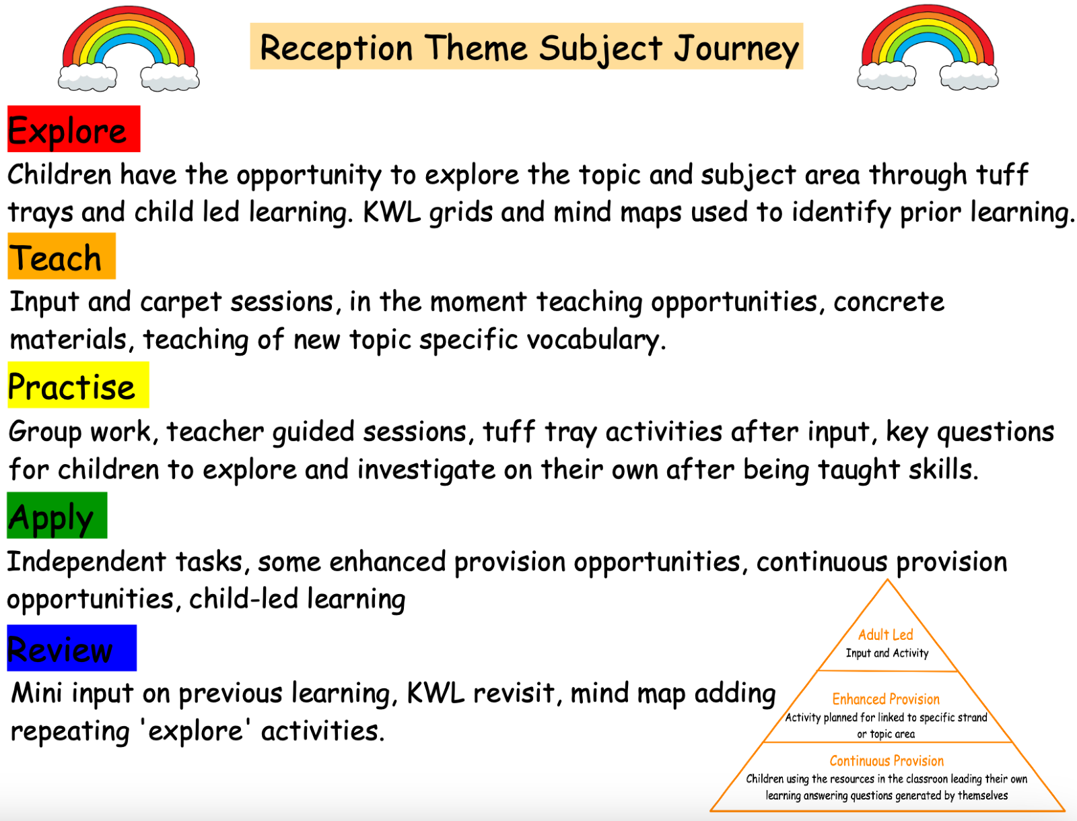

Impact

In addition to the outcomes shown on our curriculum tree the specific musical impact of the St Giles’ and St George’s Music Learning Journey is that children will:

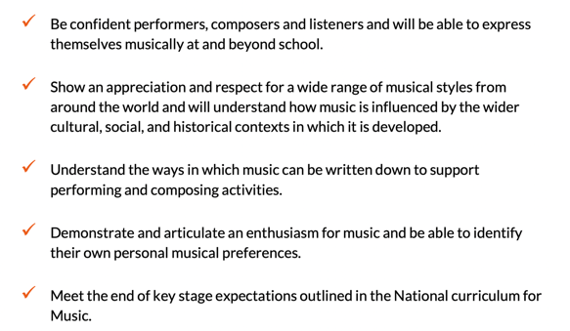

Formative assessment takes part in each lesson and misconception and next steps of the focus for feedback. Summative assessment is completed for each child at the end of each unit of teaching using the assessment framework at the end of this documents. A best fit approach to statements
achieved results in an end of year summative grade.

Our music Curriculum is based on a spiral curriculum and is planned to demonstrate progression and build on and embed current skills. We focus on progression of knowledge and skills in the different musical components and teaching of vocabulary also forms part of the units of work. If children are achieving the knowledge and skills in lessons, then they are deemed to be making good or better progress.

We measure the impact of our curriculum through the following methods:
• Pupil discussions and interviewing the pupils about their learning (pupil voice).
• Monitoring with our subject music link governor.
• Annual reporting and tracking of standards across the curriculum.
• Photo and video evidence of the pupils practical learning (saved onto Teams).
- Floor books
• Use of the assessment tools provided within the Kapow scheme.
• Dedicated music leader time.

The impact of our music curriculum is also measured in the uptake of our music after school clubs and uptake of additional music 1:1 teaching.

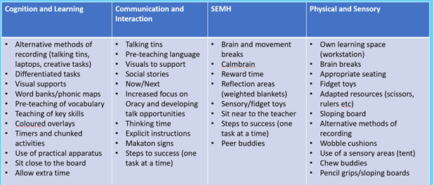
Adaptive Teaching Strategies
In our Music Lessons we cater for our SEN children using the following strategies

Our Gospel Values

EYFS  Loving and Compassionate  What do we love about our world?  Grateful and Generous  Who are the people who help us?  Curious and Active  How can everyday people be a superhero?  Faith- filled and Hopeful  Which wonderful places in the world do you hope to visit? | KS1  Loving and Compassionate  What are some of our favourite things that we love?  Curious and Active  How do the dynamics of a piece change its meaning?  Intentional and Prophetic  How is music used in religious celebrations to share the message?  Learned and Wise  What makes me special?  Faith- filled and Hopeful  When have you experienced moments of wonder?
LKS2  Learned and Wise  What is the purpose of the Earth?  Intentional and Prophetic  How can music be used to share God’s message?  Curious and Active  How does adapting motifs change the meaning of the music?  Faith- filled and Hopeful  How can singing make the world a better place?  Loving and Compassionate  How can we share feedback in a compassionate way?  Attentive and Discerning  What is the difference between hearing and listening? | UKS2  Faith-filled and hopeful  What do you hope for your future beyond primary school?  Curious and Active  Why do you like certain types of music?  Learned and Wise  What would it be like without seasons?  Loving and Compassionate – How can we share emotions through music?  Attentive and Discerning  What is the point of being creative?  Intentional and Prophetic  Would you break the law to save a loved one?

Music Overview

 | Autumn Term |  | Spring Term |  | Summer Term
 | Autumn 1 | Autumn 2 | Spring 1 | Spring 2 | Summer 1 | Summer 2
EYFS | Continuous provision based around firm foundations phonics | Exploring Sound | Celebration Music (Diwali, Christmas, Hanukah) | Music and movement  (Scarves) | Musical stories/ Traditional stories | Big Band  What makes you afraid?  
KS1 A | Keeping the Pulse  (My favourite things)  Who am I? | Tempo: Snail & Mouse | Pitch  (Musical Me) | Instruments  (Musical story telling) | Singing:  On this Island | Pitch and Tempo  (Superheroes)
KS1 B | Dynamics  (seaside) | Musical Symbols  (Under the sea) | Call and response  (Animals)  Why do we care for animals? | Contrasting Dynamics  (Space)  When have you experienced moments of wonder? | Sound Patterns  (Fairy Tales)  Is there such thing as an angel? | Structure  (Myths and Legends)  Is it ok to sometimes to give up?  Pitch  (Musical Me)
LKS2 A | Recorders  South Africa  What is the purpose of the Earth? | Recorders  Developing Singing Technique  (Vikings) | Pentatonic Melodies and composition  (Chinese New Year) | Haiku, music and performance  (Hanami festival) | Jazz  What is the difference between hearing and listening? | Adapting and transposing motifs  (Ancient Egypt)
LKS2 B | Creating a composition in response to an animation (mountains) | Rock and Roll | Ballads | Body and Tuned percussion  (Rainforests) | Changes in pitch, tempo and dynamics  (Rivers) | Samba and Carnival sounds and instruments  (South America)
UKS2 A | Ukuleles  Film Music | Ukuleles  Composition Notation  (Theme: Ancient Egypt) | Musical Theatre  What would it be like without seasons? | Theme and Variations  (Pop Art)  Why do you like certain types of music? | South and West Africa | Composing and performing a Leavers song  (Pop Music)
UKS2 B | Ukuleles  Songs of WW2  Would you break the law to save a loved one? | Ukuleles  Blues | Dynamics, pitch and texture  (Theme: Coast – Fingal’s Cave by Mendelssohn) | Composition to represent the festival of colour (Holi Festival) | Looping and Remixing  What is the point of being creative? | Composing and performing a Leavers song  (Pop Music)
Purple indicates the whole class instrumental programme as recommended by the DfE Model music curriculum 2021

National Curriculum Links

 | Listening and evaluating | Elements of music | Notation | Improvising and Composing | Performing
EYFS  Reception | Listen carefully to rhymes and songs, paying attention to how they sound. | Hear and listen  Move and dance  Explore and sing  Vocalize and sing |  | Sing songs, make music and dance and experiment with ways of changing them.  Explores the different sounds of instruments. | Perform well known nursery rhymes and familiar songs.
KS1 | Listen with concentration and understanding to a range of high-quality live and recorded  Music.  Remember and sing entire songs.  Sing the pitch of a tone sung by another person (‘pitch match’). | Experiment with, create, select and combine sounds using the inter-related dimensions of music. | Sing the melodic shape (moving melody, such as up and down, down and up) of familiar songs. | Create their own songs or improvise a song around one they know. | Play tuned and untuned instruments musically.  Use their voices expressively and creatively by singing songs and speaking chants and rhymes.
KS2 | Listen with attention to detail and recall sounds with increasing aural memory.  Appreciate and understand a wide range of high-quality live and recorded music drawn from different traditions and from great composers and musicians |  | Develop an understanding of the history of music.  Use and understand staff and other musical notations | Improvise and compose music for a range of purposes. using the inter-related dimensions of music. | Play and perform in solo and ensemble contexts, using their voices and playing musical instruments with increasing accuracy, fluency, control and expression.

Listening and Evaluation

 | EYFS  Reception | KS1 | LKS2 | UKS2
Listening and responding to music | To listen attentively and move to music.  Talk about how a piece of music makes them feel. | Describe music and sounds in simple terms using basic musical vocabulary. | Use active listening to make simple connections and  comparisons between own compositions and  performances, and those of other musicians. | Use active listening to make simple connections and  comparisons between own compositions and  performances, identifying the use of musical devices  (e.g. Canon, Ostinato, Repetition, Sequence)
Analysing | To identify and imitate sounds from a variety of music. | To identify some common instruments when listening to music. | To identify common features of musical genres. | To discuss musical eras, identifying how they have influenced each other.
Evaluating | To show preferences for certain music or sounds. | To state what they enjoyed about a peers’ performance. | To use musical vocabulary when discussing improvements to their own and other’s work. | To use musical vocabulary correctly when describing and evaluating the features of a piece of music.
Cultural and historical awareness of music |  | To listen to music from a wide variety of cultures and periods of time. | To understand that music from different times, and parts of the world, has different features. | To confidently discuss the stylistic features of different genres, styles and traditions of music.

Elements of Music

 | EYFS  Reception | KS1 | LKS2 | UKS2
Interrelated Dimensions of music | Pulse, pitch | Dynamics, rhythm, pitch, tempo | Dynamics, rhythm, pitch, tempo, timbre, structure | Dynamics, pitch, tempo, timbre, structure, texture, duration
Genre/Style | Musical stories  Big Band  Celebration music | Musical storytelling  Folk songs  Fairytales  Space  Myths and Legends | Ballads  Jazz  Samba and Carnival  Chinese New Year | Blues  Musical Theatre  Film  War songs

 | EYFS  Reception | KS1 | LKS2 | UKS2
Understanding notation |  | To recognise pitch patterns using dots and pictures.  To know that notation is read from left to right. | To understand how notes are represented in graphic notation. | To understand how notes are represented in ‘staff’ notation.
Representing pitch and rhythm |  | To know that pictorial representations can show higher and lower sounds.  To develop an awareness of how of how marks can show single beats and rests. | To use a graphic notation to record music.  To perform from basic staff notation. | To use staff notation to record music.  To perform with accuracy and fluency from staff notation including sharps and flats.
Notation
 | EYFS  Reception | KS1 | LKS2 | UKS2
Stimulus and purpose | To explore and imitate sounds in response to events and stories. | To create a sound response to a variety of stimuli (nature, artwork, story). | To compose a piece of music, in a given style, with voices, bodies and instruments. | To compose a piece of music in a chosen style, with voices, bodies and instruments.
Improvising | To explore and imitate sounds. | To improvise simple question and answer phrases, using body percussion and voices. | To improvise in a given style using voices and untuned percussion. | To improvise in a chosen style using a range of instruments.
Creating and selecting sounds | To experiment with creating sounds in different ways. | To create short sequences of sounds, with voice or an instrument.  To adapt rhythmic patterns by changing dynamics, tempo or instrument. | To develop melodies within a given structure, using the interrelated dimensions of music they have been taught. | To develop melodies, for a range of purposes using all the interrelated dimensions of music.
Sequencing | To play sounds at the relevant point in a storytelling. | To play and combine sounds under the direction of a leader (the teacher).  To work collaboratively to combine sounds either playing together or taking turns. | To compose a piece with a simple structure (binary and ternary verse/ chorus). | To compose a piece with a more complex structure (introduction/ outro, twelve bar blues).
Improvising and Composing

 | EYFS  Reception | KS1 | LKS2 | UKS2
Awareness of music | To begin to maintain a steady beat.  To chant songs and rhymes in unison. | To sing songs in unison.  To begin to play a basic melody on tuned percussion.  To clap and perform simple rhythms on untuned percussion.  To use dynamics within performances. | To sing songs with more than one part (e.g. round).  To play a melody on an instrument that they have been taught.  To manage changes of tempo in a performance. | To maintain a second or third part within a song (e.g. harmony).  To play a simple chord progression.  To perform using all of the inter-related dimensions of music they have been taught.
Awareness of self and others | To face the audience when performing.  To start and stop at the appropriate time under the guidance of a teacher. | To keep instruments still until their part in a performance.  To follow a leader to start and end a piece appropriately. | To perform actively as part of a group whilst keeping time.  To follow a leader’s gestures for dynamics. | To maintain their part when playing as part of a group.  To follow a leader’s gestures for changes in dynamics and tempo.

Performing

Prior knowledge and skills | Knowledge and skills to be taught | Next step skills
KS1 Cycle A
Keeping the Pulse - My Favourite Things

Who am I?
To sing a range of well-known nursery rhymes and songs.  To perform songs, rhymes, poems and stories with others and – when appropriate – try to move in time with music. | To clap and perform simple rhythms on untuned percussion.  To adapt rhythmic patterns by changing dynamics, tempo or instrument.  To sing songs in unison.  To create a sound response to a variety of stimuli (nature, artwork, story).  To develop an awareness of how of how marks can show single beats and rests. | To sing songs with more than one part (e.g. round).  To play a melody on an instrument that they have been taught.  To compose a piece of music in a chosen style, with voices, bodies and instruments.
Key Vocabulary
Singing voice | Pulse, fast, slow, speaking voice, thinking voice | Round, harmony
Instruments
Claves, woodblocks, triangles, drums, tambourines

NB: Listening and Evaluation should be taught in every unit.
NB:
Topic Overviews for Planning and Assessment

NB: Listening and Evaluation should be taught in every unit.
NB:
\

Prior knowledge and skills | Knowledge and skills to be taught | Next step skills
KS1 Cycle A
Tempo – Snail and Mouse
To sing a range of well-known nursery rhymes and songs. | To clap and perform simple rhythms on untuned percussion.  To adapt rhythmic patterns by changing dynamics, tempo or instrument.  To sing songs in unison.  To develop an awareness of how of how marks can show single beats and rests.  To follow a leader to start and end a piece appropriately. | To sing songs with more than one part (e.g. round).  To play a melody on an instrument that they have been taught.  To follow a leader’s gestures for changes in dynamics and tempo.
Key Vocabulary
Singing voice, slow | Beat, tempo, pattern, warm up, unison, single beat, rest | Round, harmony, melody
Instruments
Voice and body percussion, shakers & claves

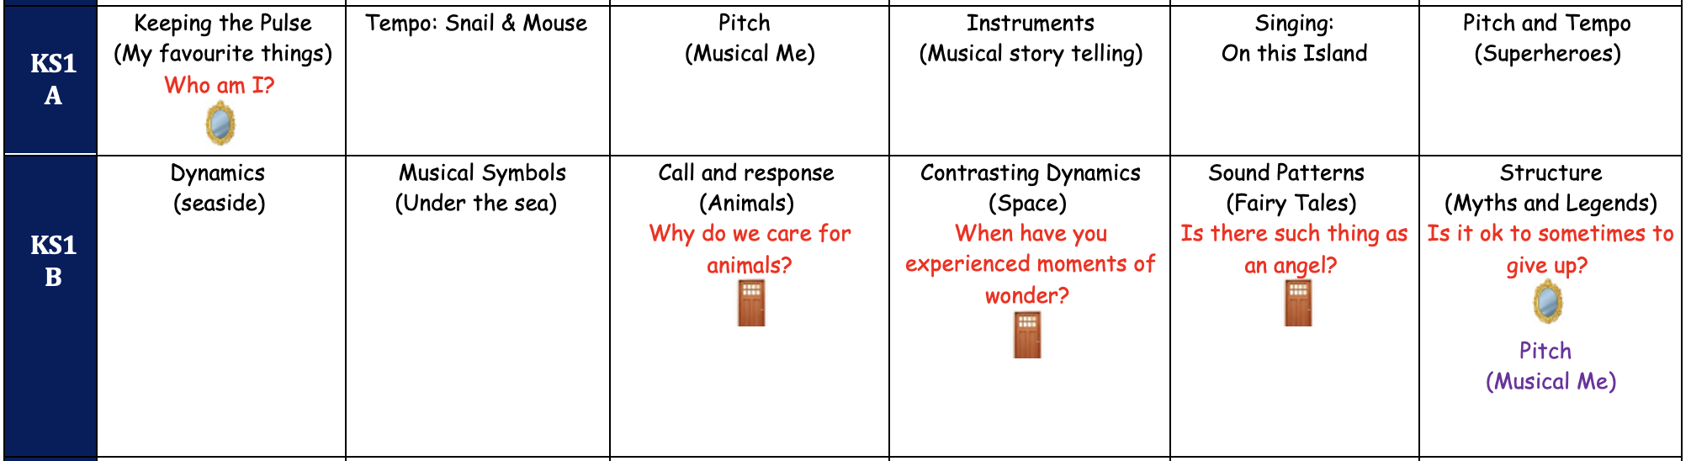

NB: Listening and Evaluation should be taught in every unit.
NB:

Prior knowledge and skills | Knowledge and skills to be taught | Next step skills
KS1 Cycle A
Pitch – Musical Me
Sing a range of well-known nursery rhymes and songs.  To perform songs, rhymes, poems and stories with others and – when appropriate – try to move in time with music. | To recognise pitch patterns using dots and pictures.  To know that notation is read from left to right.  To know that pictorial representations can show higher and lower sounds.  To sing songs in unison.  To create short sequences of sounds, with voice or an instrument.  To adapt rhythmic patterns by changing dynamics, tempo or instrument. | To use a graphic notation to record music.  To sing songs with more than one part (e.g. round).  To play a melody on an instrument that they have been taught.  To follow a leader’s gestures for changes in dynamics and tempo.
Key Vocabulary
Low, high | Dot, musical sentence, notation, phrase, pitch, pitch pattern, stave | Graphic notation
Instruments
Glockenspiels

NB: Listening and Evaluation should be taught in every unit.
NB:
Prior knowledge and skills | Knowledge and skills to be taught | Next step skills
KS1 Cycle A
Instruments – Musical Storytelling
To perform songs, rhymes, poems and stories with others and – when appropriate – try to move in time with music. | To create a sound response to a variety of stimuli (nature, artwork, story).  To create short sequences of sounds, with voice or an instrument.  To adapt rhythmic patterns by changing dynamics, tempo or instrument.  To play and combine sounds under the direction of a leader (the teacher).  To work collaboratively to combine sounds either playing together or taking turns. | To compose a piece of music, in a given style, with voices, bodies and instruments.  To develop melodies within a given structure, using the interrelated dimensions of music they have been taught.  To compose a piece with a simple structure (binary and ternary verse/ chorus).
Key Vocabulary
Stories | Loud, quiet, dynamics, encore, instrumental sound, sound effect, tempo, orchestra | Binary, ternary, verse, chorus,
Instruments
Claves, woodblock, triangle, drum, castanets

NB: Listening and Evaluation should be taught in every unit.
NB:

Prior knowledge and skills | Knowledge and skills to be taught | Next step skills
KS1 Cycle A
Singing – On this Island
To sing a range of well-known nursery rhymes and songs.  To perform songs, rhymes, poems and stories with others and – when appropriate – try to move in time with music. | To sing songs in unison.  To know that notation is read from left to right.  To create a sound response to a variety of stimuli (nature, artwork, story).  To work collaboratively to combine sounds either playing together or taking turns.  To keep instruments still until their part in a performance.  To create short sequences of sounds, with voice or an instrument. | To sing songs with more than one part (e.g. round).  To compose a piece of music, in a given style, with voices, bodies and instruments.  To develop melodies within a given structure, using the interrelated dimensions of music they have been taught.  To compose a piece with a simple structure (binary and ternary verse/ chorus).
Key Vocabulary
Loud, quiet | Composer, composition, dynamics, inspiration, pitch | Structure, binary, ternary
Instruments
Voice

NB: Listening and Evaluation should be taught in every unit.
NB:

Prior knowledge and skills | Knowledge and skills to be taught | Next step skills
KS1 Cycle A
Pitch and Tempo – Superheroes
To sing a range of well-known nursery rhymes and songs. | To create a sound response to a variety of stimuli (nature, artwork, story).  To create short sequences of sounds, with voice or an instrument.  To play and combine sounds under the direction of a leader (the teacher).  To recognise pitch patterns using dots and pictures.  To follow a leader to start and end a piece appropriately. | To compose a piece of music, in a given style, with voices, bodies and instruments.  To develop melodies within a given structure, using the interrelated dimensions of music they have been taught.  To compose a piece with a simple structure (binary and ternary verse/ chorus).  To understand how notes are represented in graphic notation.  To follow a leader’s gestures for dynamics.
Key Vocabulary
High, low | Pitch pattern, soundscape, performance, pitch, tempo | Graphic notation
Instruments
Glockenspiel

NB: Listening and Evaluation should be taught in every unit.
NB:

Prior knowledge and skills | Knowledge and skills to be taught | Next step skills
KS1 Cycle B
Dynamics - seaside
Sing a range of well-known nursery rhymes and songs. | To create a sound response to a variety of stimuli (nature, artwork, story).  To create short sequences of sounds, with voice or an instrument.  To play and combine sounds under the direction of a leader (the teacher).  To know that notation is read from left to right.  To follow a leader to start and end a piece appropriately. | To compose a piece of music, in a given style, with voices, bodies and instruments.  To develop melodies within a given structure, using the interrelated dimensions of music they have been taught.  To compose a piece with a simple structure (binary and ternary verse/ chorus).  To understand how notes are represented in graphic notation.  To follow a leader’s gestures for dynamics.
Key Vocabulary
Singing voice, loud, quiet | Instrument, dynamics, seaside, soundscape, symbol, volume | Structure, graphic notation, melodies, binary
Instruments
Body, voice and range of percussion

NB: Listening and Evaluation should be taught in every unit.
NB:

Prior knowledge and skills | Knowledge and skills to be taught | Next step skills
KS1 Cycle B
Musical Symbols – Under the sea
To perform songs, rhymes, poems and stories with others and – when appropriate – try to move in time with music. | To create a sound response to a variety of stimuli (nature, artwork, story).  To create short sequences of sounds, with voice or an instrument.  To play and combine sounds under the direction of a leader (the teacher).  To recognise pitch patterns using dots and pictures.  To follow a leader to start and end a piece appropriately. | To compose a piece of music, in a given style, with voices, bodies and instruments.  To develop melodies within a given structure, using the interrelated dimensions of music they have been taught.  To compose a piece with a simple structure (binary and ternary verse/ chorus).  To understand how notes are represented in graphic notation.  To follow a leader’s gestures for dynamics.
Key Vocabulary
 | Pitch, dynamics, rest, sound pattern, tempo | Graphic notation, gesture
Instruments
Glockenspiels, chime bars, triangles

NB: Listening and Evaluation should be taught in every unit.
NB:
Prior knowledge and skills | Knowledge and skills to be taught | Next step skills
KS1 Cycle B

Call and Response – Animals
Why do we care for animals?
To perform songs, rhymes, poems and stories with others and – when appropriate – try to move in time with music. | To improvise simple question and answer phrases, using body percussion and voices.  To create short sequences of sounds, with voice or an instrument.  To clap and perform simple rhythms on untuned percussion.  To adapt rhythmic patterns by changing dynamics, tempo or instrument.  To work collaboratively to combine sounds either playing together or taking turns. | To improvise in a given style using voices and untuned percussion.  To develop melodies within a given structure, using the interrelated dimensions of music they have been taught.  To compose a piece with a simple structure (binary and ternary verse/ chorus).
Key Vocabulary
 | Call and response, sound pattern, dynamics | Structure,
Instruments
Glockenspiels, chime bars, triangles

NB: Listening and Evaluation should be taught in every unit.
NB:

Prior knowledge and skills | Knowledge and skills to be taught | Next step skills
KS1 Cycle B
Contrasting Dynamics – Space
When have you experienced moments of wonder?
To perform songs, rhymes, poems and stories with others and – when appropriate – try to move in time with music. | To use dynamics within performances.  To create a sound response to a variety of stimuli (nature, artwork, story).  To create short sequences of sounds, with voice or an instrument.  To play and combine sounds under the direction of a leader (the teacher).  To recognise pitch patterns using dots and pictures.  To follow a leader to start and end a piece appropriately. | To manage changes of tempo in a performance.  To compose a piece of music, in a given style, with voices, bodies and instruments.  To develop melodies within a given structure, using the interrelated dimensions of music they have been taught.  To compose a piece with a simple structure (binary and ternary verse/ chorus).  To understand how notes are represented in graphic notation.  To follow a leader’s gestures for dynamics.
Key Vocabulary
Fast, slow | Composer, dynamics, pitch pattern, planet, representation, soundscape, tempo
Instruments
Glockenspiels, chime bars, triangles

Prior knowledge and skills | Knowledge and skills to be taught | Next step skills
KS1 Cycle B
Sound Patterns – Fairy Tales
Is there such a thing as an angel?
To sing a range of well-known nursery rhymes and songs.  To perform songs, rhymes, poems and stories with others and – when appropriate – try to move in time with music. | To create a sound response to a variety of stimuli (nature, artwork, story).  To create short sequences of sounds, with voice or an instrument.  To play and combine sounds under the direction of a leader (the teacher).  To keep instruments still until their part in a performance.  To follow a leader to start and end a piece appropriately. | To compose a piece of music, in a given style, with voices, bodies and instruments.  To perform actively as part of a group whilst keeping time.  To develop melodies within a given structure, using the interrelated dimensions of music they have been taught.  To follow a leader’s gestures for dynamics.
Key Vocabulary
Voice | Character, sound pattern
Instruments
Woodblocks, claves, drums, rainmakers, castanets, boomwhackers

NB: Listening and Evaluation should be taught in every unit.
NB:

NB: Listening and Evaluation should be taught in every unit.
NB:

Prior knowledge and skills | Knowledge and skills to be taught | Next step skills
KS1 Cycle B
Structure – Myths and Legends
Is it ok to sometimes to give up?
To sing a range of well-known nursery rhymes and songs.  To perform songs, rhymes, poems and stories with others and – when appropriate – try to move in time with music. | To create a sound response to a variety of stimuli (nature, artwork, story).  To begin to play a basic melody on tuned percussion.  To create short sequences of sounds, with voice or an instrument.  To work collaboratively to combine sounds either playing together or taking turns.  To keep instruments still until their part in a performance.  To follow a leader to start and end a piece appropriately. | To compose a piece of music, in a given style, with voices, bodies and instruments.  To play a melody on an instrument that they have been taught.  To develop melodies within a given structure, using the interrelated dimensions of music they have been taught.  To compose a piece with a simple structure (binary and ternary verse/ chorus).  To perform actively as part of a group whilst keeping time.  To follow a leader’s gestures for dynamics.
Key Vocabulary
 | Legend, myth, composition, notation, rest, rhythm, structure, tempo, two half beats, one beat, pulse, rest | Binary, ternary
Instruments
Woodblocks, claves, drums, rainmakers, castanets, boomwhackers

NB: Listening and Evaluation should be taught in every unit.
NB:

LKS2 Cycle A

Prior knowledge and skills | Knowledge and skills to be taught | Next step skills
LKS2 Cycle A
Recorders/ South Africa
What is the purpose of Earth?
To create a sound response to a variety of stimuli (nature, artwork, story).  To create short sequences of sounds, with voice or an instrument.  To adapt rhythmic patterns by changing dynamics, tempo or instrument. |  | To perform from basic staff notation.  To compose a piece of music, in a given style, with voices, bodies and instruments.  To develop melodies within a given structure, using the interrelated dimensions of music they have been taught.
Key Vocabulary
Instruments
Recorders

NB: Listening and Evaluation should be taught in every unit.
NB:

Prior knowledge and skills | Knowledge and skills to be taught | Next step skills
LKS2 Cycle A
Recorders / Developing Singing Technique - Vikings
Key Vocabulary
Instruments
Recorders

NB: Listening and Evaluation should be taught in every unit.
NB:

Prior knowledge and skills | Knowledge and skills to be taught | Next step skills
LKS2 Cycle A
Pentatonic Melodies and Composition – Chinese New Year
To develop an awareness of how of how marks can show single beats and rests.  To begin to play a basic melody on tuned percussion.  To work collaboratively to combine sounds either playing together or taking turns.  To keep instruments still until their part in a performance. | To perform from basic staff notation.  To compose a piece with a simple structure (binary and ternary verse/ chorus).  To play a melody on an instrument that they have been taught.  To perform actively as part of a group whilst keeping time. | To perform with accuracy and fluency from staff notation including sharps and flats.  To compose a piece with a more complex structure.  To maintain their part when playing as part of a group.
Key Vocabulary
Tempo, dynamics | Crescendo, timbre, duration, pentatonic scale, notation, graphic score, fluency, accuracy, control, expression
Instruments
Glockenspiels, chime bars, range of tuned & untuned percussion

NB: Listening and Evaluation should be taught in every unit.
NB:

Prior knowledge and skills | Knowledge and skills to be taught | Next step skills
LKS2 Cycle A
Haiku, music and performance – Hanami Festival
To create a sound response to a variety of stimuli (nature, artwork, story).  To adapt rhythmic patterns by changing dynamics, tempo or instrument.  To play and combine sounds under the direction of a leader (the teacher).  To begin to play a basic melody on tuned percussion.  To keep instruments still until their part in a performance. | To compose a piece of music, in a given style, with voices, bodies and instruments.  To improvise in a given style using voices and untuned percussion.  To compose a piece with a simple structure (binary and ternary verse/ chorus).  To play a melody on an instrument that they have been taught.  To perform actively as part of a group whilst keeping time. | To compose a piece of music in a chosen style, with voices, bodies and instruments.  To develop melodies, for a range of purposes using all the interrelated dimensions of music.  To compose a piece with a more complex structure.  To play a simple chord progression.  To maintain their part when playing as part of a group.
Key Vocabulary
Syllable, tempo, structure | Col legno, forte, glissando, haiku, pizzicato, sliding pitch, staccato, texture, timbre
Instruments
Variety of tuned and untuned percussion, own instruments

NB: Listening and Evaluation should be taught in every unit.
NB:

Prior knowledge and skills | Knowledge and skills to be taught | Next step skills
LKS2 Cycle A
Jazz
What is the difference between hearing and listening?
To create a sound response to a variety of stimuli (nature, artwork, story).  To sing songs in unison.  To improvise simple question and answer phrases, using body percussion and voices.  To begin to play a basic melody on tuned percussion.  To know that pictorial representations can show higher and lower sounds.  To develop an awareness of how of how marks can show single beats and rests. | To compose a piece of music, in a given style, with voices, bodies and instruments.  To sing songs with more than one part (e.g. round).  To improvise in a given style using voices and untuned percussion.  To play a melody on an instrument that they have been taught.  To use a graphic notation to record music.  To perform from basic staff notation. | To compose a piece of music in a chosen style, with voices, bodies and instruments.  To maintain a second or third part within a song (e.g. harmony).  To improvise in a chosen style using a range of instruments.  To play a simple chord progression.  To use staff notation to record music.  To perform with accuracy and fluency from staff notation including sharps and flats.
Key Vocabulary
Call and response, beat | Traditional jazz, improvisation, jazz, off- motif, ragtime, scat singing, straight quaver, strung quaver, swung rhythm, swing music, syncopation, tune
Instruments
Glockenspiels, boom whackers, chime bars, own instruments

NB: Listening and Evaluation should be taught in every unit.
NB:

Prior knowledge and skills | Knowledge and skills to be taught | Next step skills
LKS2 Cycle A
Adapting and transposing motifs – Ancient Egypt
To create a sound response to a variety of stimuli (nature, artwork, story).  To improvise simple question and answer phrases, using body percussion and voices.  To create short sequences of sounds, with voice or an instrument.  To adapt rhythmic patterns by changing dynamics, tempo or instrument.  To know that pictorial representations can show higher and lower sounds. | To compose a piece of music, in a given style, with voices, bodies and instruments.  To improvise in a given style using voices and untuned percussion.  To develop melodies within a given structure, using the interrelated dimensions of music they have been taught.  To use a graphic notation to record music. | To compose a piece of music in a chosen style, with voices, bodies and instruments.  To improvise in a chosen style using a range of instruments.  To develop melodies, for a range of purposes using all the interrelated dimensions of music.  To use staff notation to record music.
Key Vocabulary
Beat, pitch, tempo | Backing track, bass line, crotchet, dotted minim, flats, graphic notation, key signature, minim, motif, notation, ostinato, quavers, repeating patterns, repetition, rhythm, rhythmic notation, riff, semibreve, sharps, transpose
Instruments
Glockenspiels, chime bars, untuned percussion, own instruments

NB: Listening and Evaluation should be taught in every unit.
NB:
LKS2 Cycle B

Prior knowledge and skills | Knowledge and skills to be taught | Next step skills
LKS2 Cycle B
Recorders / Creating a composition in response to an animation - mountains
What is the purpose of Earth?

To know that notation is read from left to right.  To know that pictorial representations can show higher and lower sounds.  To create a sound response to a variety of stimuli (nature, artwork, story).  To keep instruments still until their part in a performance. | To understand how notes are represented in graphic notation.  To use a graphic notation to record music.  To compose a piece of music, in a given style, with voices, bodies and instruments.  To perform actively as part of a group whilst keeping time. | To understand how notes are represented in ‘staff’ notation.  To use staff notation to record music.  To compose a piece of music in a chosen style, with voices, bodies and instruments.  To maintain their part when playing as part of a group.
Key Vocabulary
Compose, dynamics, notation, pitch, soundscape, tempo, tuned percussion, untuned percussion | Composition, ensemble, letter notation, melodic pattern, melody, timbre
Instruments
Glockenspiels, range of tuned & untuned percussion, tablets/ laptops

NB: Listening and Evaluation should be taught in every unit.
NB:

Prior knowledge and skills | Knowledge and skills to be taught | Next step skills
LKS2 Cycle B
Rock and Roll
To sing songs in unison.  To begin to play a basic melody on tuned percussion.  To keep instruments still until their part in a performance.  To follow a leader to start and end a piece appropriately. | To sing songs with more than one part (e.g. round).  To play a melody on an instrument that they have been taught.  To perform actively as part of a group whilst keeping time.  To follow a leader’s gestures for dynamics. | To maintain a second or third part within a song (e.g. harmony).  To play a simple chord progression.  To maintain their part when playing as part of a group.  To follow a leader’s gestures for changes in dynamics and tempo.
Key Vocabulary
Vocals | Bass line, flat notes, hand jive, in-time, in-tune, notation, rock and roll, sequence, sharp notes, verse, walking bass line
Instruments
Shakers, drums, tambourines, glockenspiels

Prior knowledge and skills | Knowledge and skills to be taught | Next step skills
LKS2 Cycle B
Ballads
To sing songs in unison.  To create a sound response to a variety of stimuli (nature, artwork, story).  To keep instruments still until their part in a performance.  To start and stop at the appropriate time under the guidance of a teacher. | To sing songs with more than one part (e.g. round).  To compose a piece of music, in a given style, with voices, bodies and instruments.  To perform actively as part of a group whilst keeping time.  To follow a leader’s gestures for dynamics. | To maintain a second or third part within a song (e.g. harmony).  To compose a piece of music in a chosen style, with voices, bodies and instruments.  To maintain their part when playing as part of a group.  To follow a leader’s gestures for changes in dynamics and tempo.
Key Vocabulary
Compose, performance | Ballad, chorus, ensemble, features, instrumentals, lyrics, stanza, story mountain, verse-chorus structure.
Instruments
Voices

NB: Listening and Evaluation should be taught in every unit.
NB:

NB: Listening and Evaluation should be taught in every unit.
NB:

Prior knowledge and skills | Knowledge and skills to be taught | Next step skills
LKS2 Cycle B
Body and tuned percussion - Rainforests
To create a sound response to a variety of stimuli (nature, artwork, story).  To improvise simple question and answer phrases, using body percussion and voices.  To create short sequences of sounds, with voice or an instrument.  To keep instruments still until their part in a performance. | To compose a piece of music, in a given style, with voices, bodies and instruments.  To improvise in a given style using voices and untuned percussion.  To develop melodies within a given structure, using the interrelated dimensions of music they have been taught.  To perform actively as part of a group whilst keeping time. | To compose a piece of music in a chosen style, with voices, bodies and instruments.  To improvise in a chosen style using a range of instruments.  To develop melodies, for a range of purposes using all the interrelated dimensions of music.  To maintain their part when playing as part of a group.
Key Vocabulary
Dynamics, pitch, tempo, tune | Body percussion, combine, contrasting rhythms, layers, loop, repeated melodies, sections, structure, texture
Instruments
Glockenspiels, drums, tambours, tambourines

NB: Listening and Evaluation should be taught in every unit.
NB:

Prior knowledge and skills | Knowledge and skills to be taught | Next step skills
LKS2 Cycle B
Changes in pitch, tempo and dynamics - rivers
To sing songs in unison.  To create a sound response to a variety of stimuli (nature, artwork, story).  To keep instruments still until their part in a performance. | To sing songs with more than one part (e.g. round).  To compose a piece of music, in a given style, with voices, bodies and instruments.  To perform actively as part of a group whilst keeping time. | To maintain a second or third part within a song (e.g. harmony).  To compose a piece of music in a chosen style, with voices, bodies and instruments.  To maintain their part when playing as part of a group.
Key Vocabulary
Pitch, tempo, dynamics | A capella, breath control, cue, diction, harmony line, ostinato, in the round, vocal ostinato. | Accelerando, descending
Instruments
Range of untuned percussion

NB: Listening and Evaluation should be taught in every unit.
NB:

Prior knowledge and skills | Knowledge and skills to be taught | Next step skills
LKS2 Cycle B
Samba and Carnival sounds and instruments – South America

To improvise simple question and answer phrases, using body percussion and voices.  To create a sound response to a variety of stimuli (nature, artwork, story).  To play and combine sounds under the direction of a leader (the teacher).  To keep instruments still until their part in a performance. | To improvise in a given style using voices and untuned percussion.  To compose a piece of music, in a given style, with voices, bodies and instruments.  To compose a piece with a simple structure (binary and ternary verse/ chorus).  To perform actively as part of a group whilst keeping time. | To improvise in a chosen style using a range of instruments.  To compose a piece of music in a chosen style, with voices, bodies and instruments.  To compose a piece with a more complex structure.  To maintain their part when playing as part of a group.
Key Vocabulary
Pulse | Agogo, bateria, caixa, carnival, chocalho, cowbell, ganza, metronome, repique, rhythmic break, samba, samba breaks, surdo, syncopated rhythms, tamborim.
Instruments
Untuned percussion

NB: Listening and Evaluation should be taught in every unit.
NB:

Prior knowledge and skills | Knowledge and skills to be taught
UKS2 Cycle A
Ukuleles / Film Music
To understand how notes are represented in graphic notation.  To use a graphic notation to record music.  To improvise in a given style using voices and untuned percussion.  To manage changes of tempo in a performance.  To perform actively as part of a group whilst keeping time. | To understand how notes are represented in ‘staff’ notation.  To use staff notation to record music.  To improvise in a chosen style using a range of instruments.  To perform using all of the inter-related dimensions of music they have been taught.  To maintain their part when playing as part of a group.
Key Vocabulary
Composition, crescendo, pitch, texture, unison, major, minor, pitch | Accelerando, characteristics, clashing, descending, melodic, military, modulate, solo, soundtrack, tension, tremolo
Instruments
Ukuleles, selection of instruments, tablets/ laptops

NB: Listening and Evaluation should be taught in every unit.
NB:

Prior knowledge and skills | Knowledge and skills to be taught
UKS2 Cycle A
Ukuleles/ Composition Notation – Ancient Egypt
To sing songs with more than one part (e.g. round).  To use a graphic notation to record music.  To improvise in a given style using voices and untuned percussion.  To develop melodies within a given structure, using the interrelated dimensions of music they have been taught.  To perform actively as part of a group whilst keeping time.  To follow a leader’s gestures for dynamics. | To maintain a second or third part within a song (e.g. harmony).  To use staff notation to record music.  To improvise in a chosen style using a range of instruments.  To develop melodies, for a range of purposes using all the interrelated dimensions of music.  To maintain their part when playing as part of a group.  To follow a leader’s gestures for changes in dynamics and tempo.
Key Vocabulary
Crotchet, quaver, semibreve, minim, structure, tempo, tune, unison | Dotted minim, ensemble, minor key, notation, sheet music, staff notation, stave
Instruments
Tuned percussion

NB: Listening and Evaluation should be taught in every unit.
NB:

Prior knowledge and skills | Knowledge and skills to be taught
UKS2 Cycle A
Musical Theatre
To sing songs with more than one part (e.g. round).  To compose a piece of music, in a given style, with voices, bodies and instruments.  To perform actively as part of a group whilst keeping time.  To follow a leader’s gestures for dynamics. | To maintain a second or third part within a song (e.g. harmony).  To compose a piece of music in a chosen style, with voices, bodies and instruments.  To maintain their part when playing as part of a group.  To follow a leader’s gestures for changes in dynamics and tempo.
Key Vocabulary
Ensemble, solo, tempo, timbre | Book musical, character song, choreographer, comic opera, designer, dialogue, director, duet, hip-hop musical, jukebox musical, librettist, lyricist, musical director, musical theatre, opera, operetta, props, rock musical, scene, transitions
Instruments
Tuned and untuned percussion, own instruments, recording device

NB: Listening and Evaluation should be taught in every unit.
NB:

Prior knowledge and skills | Knowledge and skills to be taught
UKS2 Cycle B
Theme and Variations – Pop Art
Why do you like certain types of music?
To improvise in a given style using voices and untuned percussion.  To compose a piece of music, in a given style, with voices, bodies and instruments.  To develop melodies within a given structure, using the interrelated dimensions of music they have been taught.  To sing songs with more than one part (e.g. round).  To manage changes of tempo in a performance.  To perform actively as part of a group whilst keeping time. | To improvise in a chosen style using a range of instruments.  To compose a piece of music in a chosen style, with voices, bodies and instruments.  To develop melodies, for a range of purposes using all the interrelated dimensions of music.  To maintain a second or third part within a song (e.g. harmony).  To perform using all of the inter-related dimensions of music they have been taught.  To maintain their part when playing as part of a group.
Key Vocabulary
Phrases, pitch, pulse, quaver, section, semi-quaver, tempo | 3/4 time, 4/4 time, accidentals, legato, motif, pizzicato, rhythmic elements, staccato, theme, TIKI-TIKI, TI-TIKI, TIKI-TI, translate, variations, vocal line
Instruments
Ukuleles, glockenspiels, own instruments

NB: Listening and Evaluation should be taught in every unit.
NB:

Prior knowledge and skills | Knowledge and skills to be taught
UKS2 Cycle B
South and West Africa
To improvise in a given style using voices and untuned percussion.  To develop melodies within a given structure, using the interrelated dimensions of music they have been taught.  To manage changes of tempo in a performance.  To use a graphic notation to record music.  To compose a piece with a simple structure (binary and ternary verse/ chorus). | To improvise in a chosen style using a range of instruments.  To develop melodies, for a range of purposes using all the interrelated dimensions of music.  To perform using all of the inter-related dimensions of music they have been taught.  To use staff notation to record music.  To compose a piece with a more complex structure.
Key Vocabulary
Call and response, pulse, rests, rhythm, syncopation | A-capella, break, chord progression, diction, djembe, eight-beat break, major chord, master drummer, metronome, polyrhythms, pronunciation, pulse, ostinato, soloist
Instruments
Ukuleles, glockenspiels, drums, woodblocks, maracas

NB: Listening and Evaluation should be taught in every unit.
NB:

Prior knowledge and skills | Knowledge and skills to be taught
UKS2 Cycle A
Composing and performing a leaver’s song – Pop music
To sing songs with more than one part (e.g. round).  To understand how notes are represented in graphic notation.  To use a graphic notation to record music.  To compose a piece of music, in a given style, with voices, bodies and instruments.  To compose a piece with a simple structure (binary and ternary verse/ chorus).  To manage changes of tempo in a performance.  To follow a leader’s gestures for dynamics.  To perform actively as part of a group whilst keeping time. | To maintain a second or third part within a song (e.g. harmony).  To understand how notes are represented in ‘staff’ notation.  To use staff notation to record music.  To compose a piece of music in a chosen style, with voices, bodies and instruments.  To compose a piece with a more complex structure.  To perform using all of the inter-related dimensions of music they have been taught.  To maintain their part when playing as part of a group.  To follow a leader’s gestures for changes in dynamics and tempo.
Key Vocabulary
Lyrics, crescendo, dynamics, melody, notation, sequence | Arrangement, backing track, lyrics, chords, chord progression, diminuendo, forte, musical features, repetitive, rhyming pattern, stave notation, upbeat
Instruments
Tuned percussion, untuned percussion, own instruments, music technology

NB: Listening and Evaluation should be taught in every unit.
NB:

UKS2 Cycle B

Prior knowledge and skills | Knowledge and skills to be taught
UKS2 Cycle B

Ukuleles / Songs of WW2
Would you break the law to save a loved one?
To understand how notes are represented in graphic notation.  To perform from basic staff notation.  To develop melodies within a given structure, using the interrelated dimensions of music they have been taught.  To sing songs with more than one part (e.g. round).  To perform actively as part of a group whilst keeping time.  To follow a leader’s gestures for dynamics. | To understand how notes are represented in ‘staff’ notation.  To perform with accuracy and fluency from staff notation including sharps and flats.  To develop melodies, for a range of purposes using all the interrelated dimensions of music.  To maintain a second or third part within a song (e.g. harmony).  To maintain their part when playing as part of a group.  To follow a leader’s gestures for changes in dynamics and tempo.
Key Vocabulary
Dynamics, lyrics, phrase, pitch, tempo | Counter-melody, era, expression, graphic score, harmonise, melody line, notate, octave, parts, purpose, score, Solfa, Solfa ladder
Instruments
Voice

NB: Listening and Evaluation should be taught in every unit.
NB:

Prior knowledge and skills | Knowledge and skills to be taught
UKS2 Cycle B
Ukuleles/ Blues
To sing songs with more than one part (e.g. round).  To play a melody on an instrument that they have been taught.  To use a graphic notation to record music.  To perform actively as part of a group whilst keeping time.  To develop melodies within a given structure, using the interrelated dimensions of music they have been taught. | To maintain a second or third part within a song (e.g. harmony).  To play a simple chord progression.  To use staff notation to record music.  To maintain their part when playing as part of a group.  To develop melodies, for a range of purposes using all the interrelated dimensions of music.
Key Vocabulary
Bar, improvisation, lyrics, pitch, quavers, | 12-bar blues, ascending scale, bent notes, blues scale, chord, descending scale, flat, scale, sharp, solo, staff notation
Instruments
Glockenspiels, chime bars

NB: Listening and Evaluation should be taught in every unit.
NB:

Prior knowledge and skills | Knowledge and skills to be taught
UKS2 Cycle B
Dynamics, pitch and texture – Coast (Finghal’s Cave by Mendelssohn)
To improvise in a given style using voices and untuned percussion.  To compose a piece of music, in a given style, with voices, bodies and instruments.  To develop melodies within a given structure, using the interrelated dimensions of music they have been taught.  To use a graphic notation to record music.  To perform from basic staff notation. | To improvise in a chosen style using a range of instruments.  To compose a piece of music in a chosen style, with voices, bodies and instruments.  To develop melodies, for a range of purposes using all the interrelated dimensions of music.  To use staff notation and technology to record music.  To perform with accuracy and fluency from staff notation including sharps and flats.
Key Vocabulary
Composition, conductor, pitch, texture, dynamics, ensemble, graphic score, improvisation, notation, orchestra | Classical, characterise, depict
Instruments
Tuned percussion

NB: Listening and Evaluation should be taught in every unit.
NB:

Prior knowledge and skills | Knowledge and skills to be taught
LKS2 Cycle B
Composition to represent the festival of colour – Holi Festival
To compose a piece of music, in a given style, with voices, bodies and instruments.  To perform actively as part of a group whilst keeping time.  To manage changes of tempo in a performance.  To compose a piece with a simple structure (binary and ternary verse/ chorus).  To use a graphic notation to record music. | To compose a piece of music in a chosen style, with voices, bodies and instruments.  To maintain their part when playing as part of a group.  To perform using all of the inter-related dimensions of music they have been taught.  To compose a piece with a more complex structure.  To use staff notation and technology to record music.
Key Vocabulary
Dynamics, graphic score, pitch, tempo, texture, timbre, vocal sounds, visual representation | Inspiration, layering, mood, synesthesia,
Instruments
Range of percussion which are played by shaking, tapping or scraping with your hand or a beater.

NB: Listening and Evaluation should be taught in every unit.
NB:

Prior knowledge and skills | Knowledge and skills to be taught
UKS2 Cycle B
Looping and Remixing
What is the point of being creative?
To perform from basic staff notation.  To compose a piece of music, in a given style, with voices, bodies and instruments.  To improvise in a given style using voices and untuned percussion.  To develop melodies within a given structure, using the interrelated dimensions of music they have been taught.  To compose a piece with a simple structure (binary and ternary verse/ chorus).  To perform actively as part of a group whilst keeping time.  To manage changes of tempo in a performance. | To perform with accuracy and fluency from staff notation including sharps and flats.  To compose a piece of music in a chosen style, with voices, bodies and instruments.  To improvise in a chosen style using a range of instruments.  To develop melodies, for a range of purposes using all the interrelated dimensions of music.  To compose a piece with a more complex structure.  To maintain their part when playing as part of a group.  To perform using all of the inter-related dimensions of music they have been taught.
Key Vocabulary
Body percussion, layers, notation, rhythm, structure | Backbeat, fragment, loop, looped rhythm, melody line, ostinato, remix, riff.
Instruments
Tuned percussion, body percussion, laptops/tablets, glockenspiels, piano, iPads

NB: Listening and Evaluation should be taught in every unit.
NB:

Prior knowledge and skills | Knowledge and skills to be taught
UKS2 Cycle B
Composing and performing a leaver’s song – Pop music
To sing songs with more than one part (e.g. round).  To understand how notes are represented in graphic notation.  To use a graphic notation to record music.  To compose a piece of music, in a given style, with voices, bodies and instruments.  To compose a piece with a simple structure (binary and ternary verse/ chorus).  To manage changes of tempo in a performance.  To follow a leader’s gestures for dynamics.  To perform actively as part of a group whilst keeping time. | To maintain a second or third part within a song (e.g. harmony).  To understand how notes are represented in ‘staff’ notation.  To use staff notation to record music.  To compose a piece of music in a chosen style, with voices, bodies and instruments.  To compose a piece with a more complex structure.  To perform using all of the inter-related dimensions of music they have been taught.  To maintain their part when playing as part of a group.  To follow a leader’s gestures for changes in dynamics and tempo.
Key Vocabulary
Lyrics, backing track, crescendo, dynamics, melody, notation, sequence, verse-chorus structure | Arrangement, chords, chord progression, diminuendo, forte, musical features, rhyming pattern, stave notation, upbeat
Instruments
Tuned percussion, untuned percussion, own instruments, music technology



