
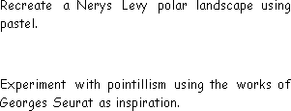
Year 2 Autumn 1 Curriculum Overview
English
Text: Dogger
Skills:
- Full stops, questions marks, exclamation marks and commas
- Sentence types
- Conjunctions
- Time adverbials

Science

Units: The Human Body, Seasonal Changes

Key questions/ experiments:
Do the oldest children have the longest feet?

What are the main changes each season?
Mathematics
Focus: Place Value
Objectives include:
- Recognise tens and ones
- Use a place value chart
- Partition numbers to 100
- Estimate, order and compare numbers
- Counts in 2s, 5s, 10s and 3s.

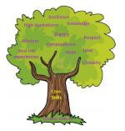
PE

Fundamentals
Explore balance, stability, jumping,
hopping, skipping and landing safely.

Forest Schools
Team building skills

Religious Education
Creation: Who Made the World?
Religion: Christianity

Key Question: What is the most beautiful thing in the world?
PSHE
Unit: Being Me In My World
Overview:
- Help others to feel welcome.
- Try to make our school community a better place.
- Care about other people’s feelings.
Music

Keeping the Pulse (My favourite
things).
- Clap and sing a rhythm in time to the pulse.
- Copy rhythms and keep the pulse while playing a rhythm on the instrument.

Computing
Art/Design Technology

Art: Making your mark (Drawing)

- To use a range of drawing materials to mark make.
- To explore tone, form and different techniques to
- represent texture.

Humanities
History - School/ Toys
Key Question: What was life like in the past?

- To know similarities and differences between their lives and those in the past.
Computing Systems & Networks
- What is a computer?
- Improving mouse skills
- Use the internet safely

