

Educational Visits Policy

Reviewed November 2025

Contents

- Rationale and Aims
- Provision of Employer Guidance
- Scope and Remit
- Roles, Responsibilities, Declarations and Approval
- Planning and Preparation – order
- Inclusion
- Risk Management and Assessment
- Volunteers
- Communication and consent
- Emergency procedures and incident reporting
- Charging and insurance
- Residential visits
- Monitoring
- Review
- Links with other policies
Appendix 1: booking form
Appendix 2: risk assessment template
Appendix 3: volunteer behaviour and code of conduct
Appendix 4: template letter for parents/carers and consent form
Appendix 5: educational visits checklist

Rationale and Aims

St Giles’ and St George’s C of E Academy acknowledges the many benefits of learning outside the classroom and is committed to supporting educational visits and activities that enrich the learning opportunities of all children and young people. The Academy is indebted to leaders who have enriched the education of past generations of pupils and students and to those who will continue this valuable work. This document sets out the Academy’s policy on managing off-site activity and learning outside the classroom.

We aim to ensure that our children, no matter what their background, have a range of hands-on experiences whilst they are a member of our school. Our educational visits are linked, where appropriate, to different areas of the curriculum. Teachers, with support from Subject Leaders, ensure that the visits will have a positive impact on the child’s learning. This policy aims to ensure the safety of our pupils whilst on educational visits and learning outside the classroom. Whilst in our school, our aim is to ensure pupils have an enriched curriculum, one way in which we do this is through well planned educational visits.

The Ofsted report ‘Learning Outside the Classroom – How Far Should You Go?’ (October 2008) makes statements in the strongest terms to support the value of LOtC, including the fact that it raises achievement. Staffordshire Heads, Managers, EVCs and Visit Leaders are recommended to familiarise themselves with the main content of this report. For further information please refer to NG documents:
5 – Policies & Evaluation | (oeapng.info)

Provision of Employer Guidance

St Giles’ and St George’s C of E Academy has formally adopted Outdoor Education Advisers’ Panel ‘National Guidance’ (NG) as its guidance for the management of off-site visits and learning outside of the classroom (LOtC). This guidance can be found on the following web site:

All documents | (oeapng.info)

It is a legal expectation that employees must work within the requirements of their employer’s guidance; therefore the academy’s employees must follow the requirements of NG, as well as the requirements of this policy statement.

Scope and Remit

The NG document:
1c-Status-Remit-and-Rationale.pdf applies to any occasion when a child, young person or vulnerable adult takes part in a visit or activity led or organised by their establishment, which is carried out beyond the boundary of the normal operational base. Such visits and activities are known by various terms including Educational Visits, School Trips, Off-Site Visits, Outings, Outdoor Learning, Outdoor Education, Adventure Education, Outdoor Activities, Learning Outside the Classroom (LOtC), Residentials, Expeditions, Field Trips and Field Studies.

OEAP National Guidance does NOT apply to:
- Physical Education (PE) activities;
- Routine travel between home and establishment;
- Routine travel between sites, where an establishment operates on a split site;
- Work experience placements.

For a more expansive explanation of legal explanations, all users of the guidance are strongly recommended to read the NG document:
3.2a Underpinning Legal Framework and Duty of Care

Roles, responsibilities, Declarations and Approval
a. Overview of Roles and Responsibilities Local Authority (LA)
- Overall Health & Safety responsibility
- Health, safety and welfare of teachers and other education staff
- Health and safety of pupils in school and on off-site visits
- Health and safety of visitors to LA establishments - and volunteers involved in any LA activity
- Manage response to, and aftermath of, any significant incidents
b. Outdoor Education Adviser (OEA)
- Establish Educational Visits Coordinators in every relevant service
- Provide support for Educational Visits Coordinators
- Approve or decline visits based on safety issues (not quality)
- Enable a clear audit trail and database
- Provide expert advice, training and monitoring
c. Headteacher
- Considers delegation of Educational Visits Coordinator’s role
- Agree who will approve the visits
- Be aware of Best Value in the planning of visits
- Ensure contingency planning
- Advise Educational Visits Coordinators
- Monitor Educational Visits Coordinators for requirements of LA and DCSF
- Approves or declines visits on grounds of safety and quality prior to OEA approval.
- Approves the trip accepted by the EVC on the following grounds:
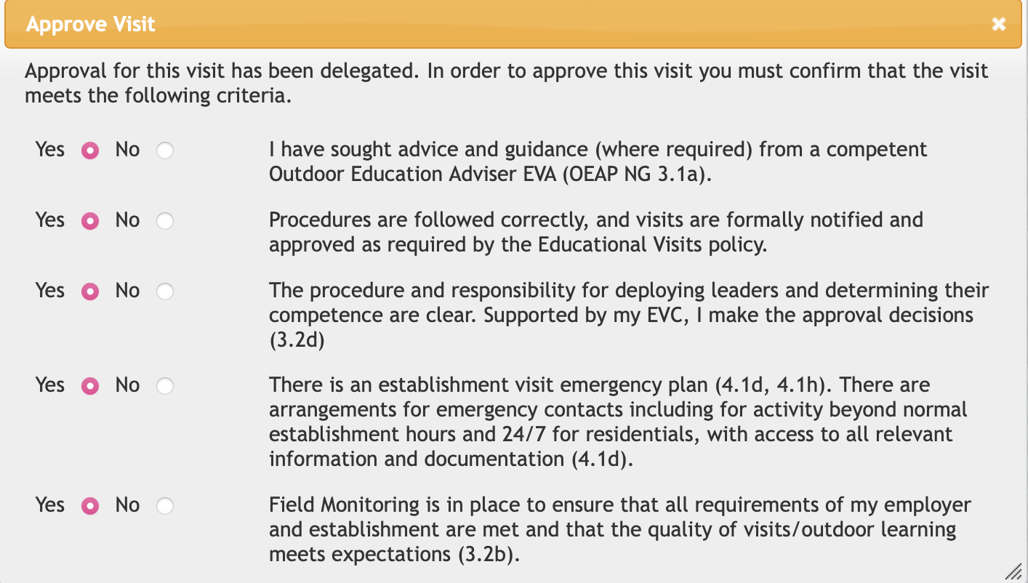
d. Educational Visits Coordinator (EVC)
- Support local management
- Ensure all visits meet Local Authority requirements
- Assess the competence of leaders
- Induct and train leaders as necessary
- Ensure emergency plans are in place and understood
- Record, review and monitor visits
- Agrees to be below declarations when reviewing a trip risk assessment: 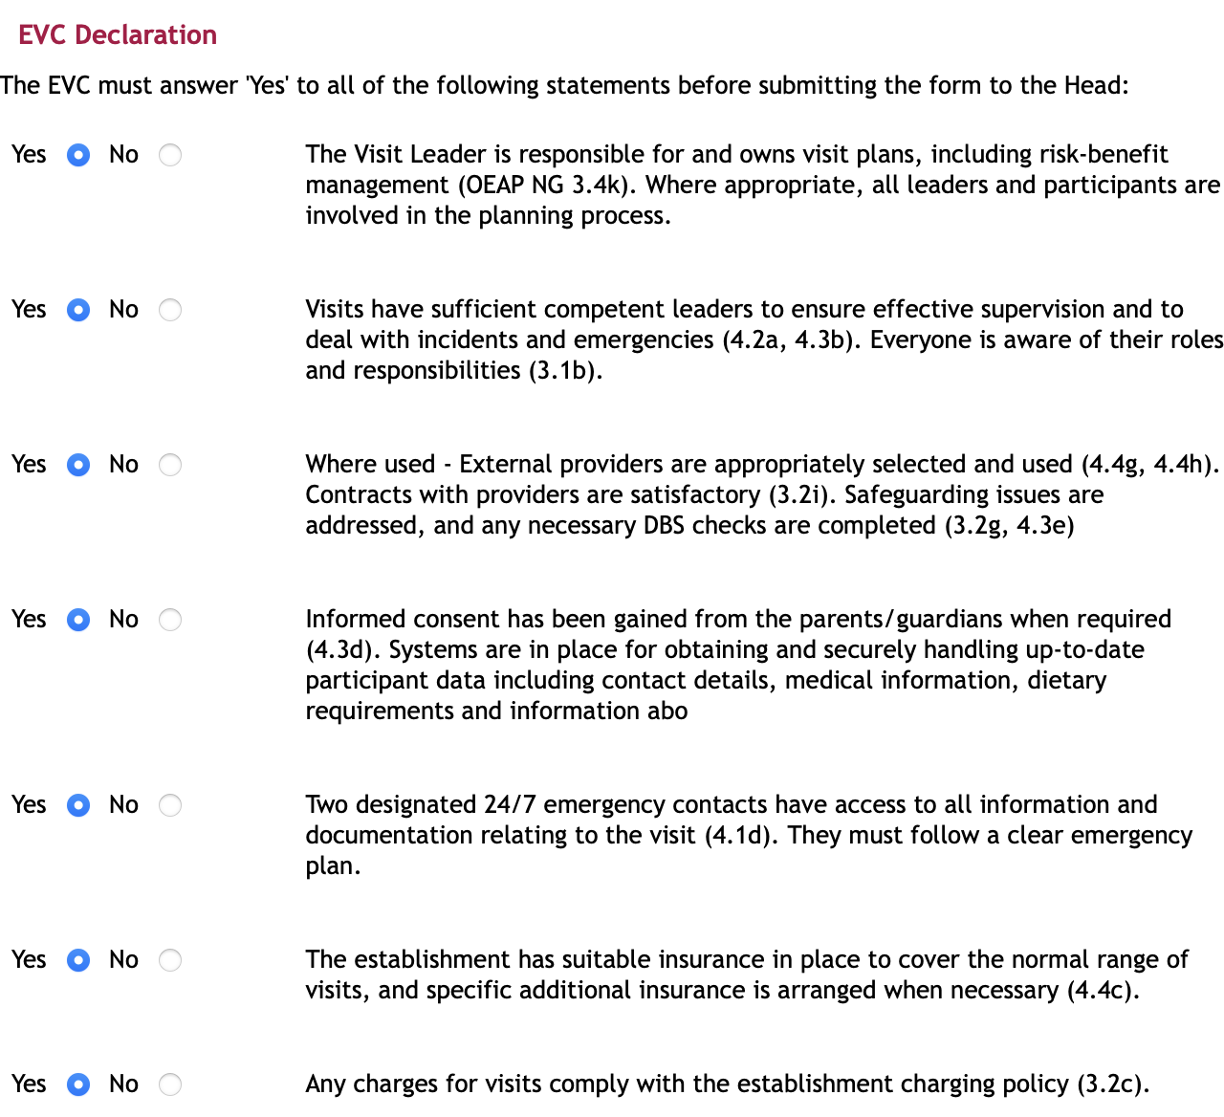
e. Visit Leader
- Plan and deliver a safe and beneficial visit work to the requirements of DCSF and the Local Authority, advised by the Educational Visits Coordinator
- Appropriately risk assess the trip and upload to EVOLVE. (4 weeks prior for residentials, 2 weeks prior for other trips)
- Immediately contact the emergency school contact if there is an incident or emergency on the trip.
- Brief adults on the trip
- Hand Risk Assessment to headteacher (paper copy) before exiting the building signed by everyone involved to show it has been read and understood.
- Evaluate trip within 1 week of return
NG provides clear advice regarding the assessment of leader competence. It is an expectation of St Giles’ and St George’s C of E Academy policy that all leaders and their assistants have been formally assessed as competent to undertake such responsibilities as they have been assigned in line with NG.

Planning and preparation

The final decision on whether or not a visit will take place will be made by Catherine Pointon (Headteacher) and based on factors including:

- Cost (including any potential cost to parents/carers)
- Timing in the school year and any potential clashes
- Educational purpose and value
- Disruption to the normal running of the school
- Health and safety considerations
- Staff-to-pupil ratio

As part of the planning stage, information will be gathered by staff proposing the visit, including:
- Location and travel distance
- Appropriateness of venue for the intended outcomes
- Cost breakdown, including multiple options where available (not including travel)
- Resources, including staffing, volunteer, and physical supplies needed
- Accommodation options, where needed
- Insurance detailed, where needed
- Risk assessment plans and first aid provision
- What safety measures can be put in place in order to reduce any risks

The visit lead will then complete the booking form (Appendix 1) and send this to the Headteacher to approve with SLT. This will then get sent to the office who will arrange the travel arrangements for the trip. When travel has been approved, the booking form will be returned to SLT to check. This will then get returned to the visit leader, along with a full price for the trip. The visit lead will then write the letter to be sent out to parents and carers. When the trip is added to the school calendar, the visit lead will need to add the members of staff needed for the trip to ensure staffing both in and out of the building can be covered.
In cases where a trip involves activities for more than 24 hours, an overnight stay and/or travel overseas, the headteacher will seek approval of the governing board. Once the risk assessment has been approved by the headteacher, and the governing board where relevant, staff will communicate with parents/carers and provide trip information.
Written parental consent will be required for trips that take place outside of normal school hours, and for any trips requiring a higher-than-normal level of risk assessment. The visit lead will complete the Evolve risk assessment and it will be accepted by the EVC. The trip will then be sent to EVA for a mandatory comment, suggestion and guidance then sent to the head for full approval.

We will evaluate each visit after its conclusion, from the planning through to the visit itself, to continually improve the planning and experience of our future visits.

Planning should reflect the consideration of legal and good practice requirements, ensuring:

- The plan is based on establishment procedures and employer guidance.
- All staff (including any adult volunteer helpers) and the young people to be involved, have a clear understanding of their roles and responsibilities, including their role in the risk management process.
- Those in a position of parental authority have been fully informed and, where appropriate, formal consents have been obtained.
- Proportionate assurances have been obtained from any providers (making full use of national schemes that accredit that assurances have already been obtained by credible inspection regimes).
- Designated emergency contact(s) have been identified that will work on a 24/7 basis where required.
- All details of the activity provision are accessible to the emergency contact throughout the period of the activity.

Careful thought must be given to planning transport to support off-site activities and visits. Statistics demonstrate that it is much more dangerous to travel to an activity than to engage in it and establishments must follow the specialist guidance provided in Staffordshire’s transport policy. All national and local regulatory requirements must be followed.

The level of supervision necessary should be considered as part of the risk management process when planning the journey, giving proper consideration to issues of driver-distraction when considering what supervision is required for the specific group of passengers being transported in a minibus. Transporting young people in private cars requires careful consideration. Where this occurs, there should be recorded procedures.

Please refer to NG documents:
4 – Good Practice | (oeapng.info) – Transport
4.5a Transport General Considerations
4.5b Transport in Minibuses
4.5c Transport in Private Cars
4.5d Seat Belts and Child Restraints
4.5e Hiring a Coach
4.5f Checklist - Assessing a Coach Hire Provider
7.1r Overseas Visits

Further information and advice is available from ‘Staffordshire’s Road Safety and Sustainable Travel Unit’:
Staffordshire County Council - Road Safety Knowledge Centre

Trip leaders should use the Checklist to support the planning process (Appendix 5).

Inclusion

We believe all children have the right to have access to an enriched curriculum. We ensure that all trips are appropriate and can accommodate all pupils in the group. Where appropriate the activities may have to be adapted to suit the needs of our pupils. This will be done in conjunction with the trip leader, EVC and the venue. Children with additional needs will be risk assessed appropriately, using our Vulnerable Pupils assessment or our Personal EV Risk Assessment (Appendix 2).

Risk Management and Assessment

As an employer, St Giles’ and St George’s Academy has a legal duty to ensure that risks are managed – requiring them to be reduced to an ‘acceptable’ or ‘tolerable’ level – and not to eliminate risks, as would be a reasonable expectation when risk assessing a piece of machinery, work shop or manufacturing process. This requires that proportional (suitable and sufficient) risk management systems are in place, requiring the academy to provide such support, training and resources to its employees as is necessary to implement this policy.

The risk management of an activity should be informed by the benefits to be gained from participating. The Academy strongly recommends a ‘risk-benefit assessment’ approach, whereby the starting point for any risk assessment should be a consideration of the targeted benefits and learning outcomes. This appreciation of the benefits to be gained through participating provides objectivity to a decision that any residual risk (i.e. the risk remaining after control measures have been put in place) is ‘acceptable’. HSE endorse this approach through their ‘Principles of Sensible Risk Management’ and advocate that it is important that young people are exposed to well-managed risks so that they learn how to manage risk for themselves.

St Giles’ and St Georges’ C of E academy requires a risk assessment in the agreed format; there is a legal requirement for the process to be recorded and for suitable and sufficient control measures to be identified for any significant risks i.e. those that may cause serious harm to an individual or harm several people. However, Staffordshire EVC training ensures that establishments are supplied with an electronic portfolio of exemplar generic risk-benefit assessments, as well as exemplar event-specific assessments. These risk management materials can also be accessed through EVOLVE.

For further information please refer to NG document:
4.3c Risk Management - an Overview

We will carry out a full risk assessment at least 2 weeks before the start of all trips and 4 weeks for residentials. This will be completed using the school’s risk assessment templates found on TEAMS and Appendix 2. We do not use previous risk assessments if the trip has happened previously as the risks need to be assessed based on cohort, venue, weather conditions etc. The risk assessment will include any specific medical issues and allergies (for staff and pupils), the role of additional support on the visit, specified activities to be carried out, as well as risks associated with transport to and from the destination.

Where practical, staff may make a preliminary visit to the trip destination as part of the planning and risk assessment process, but this is not mandatory.
Trip leads will raise any concerns or questions about potential risks and safety measures with the headteacher and, where appropriate, third party vendors.
Every risk assessment will be uploaded to EVOLVE, reviewed and submitted by the EVC and approved by the headteacher. A copy of the risk assessment documents is printed, read by all staff on the visit and signed. This is then handed to the Headteacher prior to leaving the school building.
Effective Supervision and First Aid
Risk assessments for each visit will ascertain the safe level of supervision required. On all educational visits, we will aim for:

- At least 1 supervising adult able to administer first aid is present on all trips (paediatric first aid where appropriate). Where this is not a possibility, the visit lead is expected to use sensible judgement of what first aid needs to be carried out.
- Appropriate first aid equipment will be taken on all trips, in accordance with the school’s first aid and health and safety policies. These can be found in the Meeting Room. The small first aid book will be taken, and any first aid given will be noted and parents will be informed.
- All supervising adults will be made aware of any medical issues or allergies at the start of the trip.
- Adults without a DBS check will not be left alone with pupils at any time.
- The trip lead will take regular headcounts and/or rollcalls.

In general terms, the law does not prescribe activity-specific staffing ratios; but it does require that the level of supervision and group management is ‘effective’.

Effective supervision should be determined by a proper consideration of:

- Age (including the developmental age) of the group;
- Gender issues;
- Ability of the group (including special learning needs, behavioural, medical and vulnerability characteristics etc);
- Nature and location of the activity (including the type of activity, duration, skill levels involved, as well as the time of year and prevailing conditions)
- Staff competence

As an exception to the above Ofsted and DfE guidance we prescribe ratios for Early Years at 1:8, not including 1:1 children and dependent on the level of qualifications of the adults. We will be following the latest guidance 2024 for Early Years
Early years foundation stage (EYFS) statutory framework - GOV.UK (www.gov.uk)

For further information please refer to NG documents:
- 4.3b Ratios and Effective Supervision
- 4.2a Group Management and Supervision

1:1 members of staff are not counted in the Adult to Child ratio as they will be working 1:1 with their designated child.
Transport
Transportation for trips will be organised by the school, in line with our safety procedures. We will make sure pupils, staff and volunteers are transported safely and efficiently, with the required first aid provision. Unless previously agreed with parents, transport for visits will leave from, and return to, the school site.

When using the schools minibus, all minibus drivers will have had a medical and assessment in line with the SCC Minibus Assessment Guidance. When using the minibus for a Local Area Visit or Visit outside of the classroom, the minibus risk assessment will be attached and completed as part of the Evolve form submission.
Use of external organisations
As part of the risk assessment process, we will check that any external organisations providing an activity have appropriate safety standards and liability insurance.
This includes checking that organisations hold the Learning Outside the Classroom (LOtC) Quality Badge. Where an organisation does not, we will check additional details as outlined in the DfE’s guidance on health and safety on educational visits to make sure it’s an appropriate organisation to use.
We will have a written agreement in place with each external organisation outlining what everyone is responsible for during the activity.
Volunteers

Where appropriate, parents and carers may be asked to volunteer to attend and supervise pupils alongside staff members on trips. Where more parents/carers volunteer than required on the visit, those invited to attend will be selected as fairly and transparently as possible, whilst taking into consideration:

- The needs of the pupils going on the trip
- The setting and circumstances of the trip
- Volunteers’ skills, attitude and past behaviour, including previous volunteer experience

Parents/carers selected to volunteer will be informed at least 2 weeks ahead of the visit, and asked to confirm their attendance in writing. They will also be asked to confirm they agree with the expected behaviour. See appendix 3 for our volunteer code of conduct for educational visits.
Volunteers will receive a full induction from staff members on the day of the visit, prior to departure, including on their responsibilities, expected behaviour, the process for raising concerns, emergency procedures and contact details, and the expected timetable of the trip.
Where practical and as required by the nature of visits (i.e. when volunteers may be left with children without staff members present), volunteers may be asked or required to undergo safeguarding checks, including DBS checks. At no point will volunteers on whom no safeguarding checks have been carried out be left alone with pupils or given sole responsibility for the care of a pupil.

Communication and consent

We will contact the parents and carers of pupils invited to take part in an educational visit at least 1 month before the proposed date of the trip. This may be extended to 2 months if the trip cost is more than £20 to ensure that parents have sufficient notice to make a contribution. Communication will be via letter and information provided will include the date, travel times, destination, purpose of the visit, and the size of the group attending.
We will also communicate:

- Times and details of travel, including drop-off and pick-up times and location
- Clothing and equipment required, and whether this is provided by the school
- Expected behaviour and consequences of pupils’ failure to meet these standards
- Activities being undertaken

Where required, parents/carers will be asked to provide written consent for educational visits by signing and dating a form to be returned to the school. An example letter for parents can be found in Appendix 4. Consent may be asked for through our ParentPay system.

Because most visits during the school day will be part of the curriculum, we will not always need written consent. However, we will always inform parents/carers as above about any off-site visits, and give an opportunity for them to withdraw their child. Where the child is nursery age, we will always get written consent before taking children off-site.

Parents/carers will also be asked to provide current and relevant medical information and dietary requirements, as well as emergency contact numbers where they can be reached. In the case of overseas trips, they will be asked to provide passport information and European Health Insurance Card or UK Global Health Insurance Card information, if available.

Emergency procedures and incident reporting

A critical incident is an incident where any member of a group undertaking an off-site activity has:

  - Either suffered a life threatening injury or fatality
  - Is at serious risk;
  - Or has gone missing for a significant and unacceptable period.

As an employer, the Academy is committed to providing emergency planning procedures to support establishments in the event of a critical incident. For this, we follow the Trust ‘Major Critical Incident Policy’ and the ‘Business Continuity Plan’. For further information please refer to NG document:
4.1b Emergencies and Critical Incidents – Overview

We follow the Three Spires Trust ‘Major Critical Incident Policy which gives four key stages to follow in the events of a critical incident. The initial stage is:
- Take immediate actions to preserve life, safeguard children and staff, together with their welfare, which may include invoking the site lock-down procedure or site evacuation either emergency or planned.
- Notify the emergency services (if necessary).
- Declare a critical incident as appropriate and notify key members of staff and the incident management team.
- On a continuous cycle, reassess risk and take further mitigating actions.
- Engage support of the IMT as appropriate, together with key staff.
- Take actions to preserve equipment, facilities and the built environment (if appropriate) but not at the detriment of human safety.
- Enact your local emergencies procedures.
- Gather key information and keep records. Contact the families/next of kin of those involved (remember this communication may be passed to the media)
- Ensure that the central team are notified – contact the Director of Operations and / or the Director of Safeguarding, as appropriate. Contact numbers are: Director of Operations: 07904 804962 Trust Central Support Team: 01785 526011

Generally, emergency planning will be defined as planning for:
- Serious and unexpected risk
- Serious and life-threatening injury
- Individuals going missing
- A serious breach of safeguarding expectations
The trip leader will be familiar with these plans for each visit.
In the case of an emergency, the trip leader or other supervising adult will contact the school office. The school office will then contact parents/carers as required, and inform them of changes to plans or cancellations of trips and/or alternative travel plans. This will form part of a wider communication plan that covers how routine communications should be handled in such situations.
1 member of staff will always accompany a pupil seeking medical treatment.
In a case of a pupil being unaccounted for, the trip leader will search the area while another member of staff remains in charge of other pupils. In the unlikely event that a pupil cannot be found within 30 minutes, the trip leader will contact the school office who will notify the parents/carers. The trip leader will then contact the police and provide them with the relevant information so they can take over the search, staying with them to comfort the pupil when found. The remaining staff and adults will return to the school with the rest of the pupils.
All incidents and accidents will be reported in line with our health and safety policy, including required reporting to Ofsted and the Health and Safety Executive (HSE).
Smaller incidents, accidents or near misses that do not require external reporting will still be covered by an internal report, to include steps that can be taken in the future to avoid similar incidents.
There will also be a clear process for evaluating all visits and trips once they have been concluded from the planning through to the visit itself. This will help with evaluating whether planning worked and to learn from any incidents that took place.

If a critical incident occurs (Group Leader responsibilities)
- Take charge and assess the situation quickly.
- Call emergency services.
- Identify any casualties and ensure they receive medical attention.
- Keep the rest of the group safe, together, and supervised.
- Ensure all staff and pupils follow emergency procedures.
- Send a staff member with any casualty to hospital.
- Contact the school’s designated contact and provide key details (what happened, who is involved, injuries, actions taken).
- If abroad, notify the British Embassy/Consulate.
- Inform the tour operator and insurers as required.
- Record all key facts, times, actions, and witness details in writing.
- Do not speak to the media; direct enquiries to the school’s media contact.
- Do not discuss legal liability.

School contact responsibilities
- Confirm the Group Leader has the situation under control and offer support from school.
- Notify the Head/Deputy and liaise throughout.
- Ensure parents of affected pupils are contacted personally by the Head/Deputy.
- Keep parents informed and act as the communication link between school and the group.
- Maintain a full written record of all information received and actions taken.
- Direct all media enquiries to the designated media contact.

After the incident
- Monitor pupils and staff for possible delayed trauma responses.
- Seek professional support if needed for individuals or the wider school community.

Charging and Insurance

Staffordshire Heads and Managers, Curriculum Planners, EVCs and Visit Leaders must take account of the legal framework relating to charging, voluntary contributions and remissions as set out in sections 449-462 of the Education Act 1996. For further information please refer to NG document:
3.2c Charging for School Activities

Preliminary Visits and Provider Assurances
All visits should be thoroughly researched to establish the suitability of the venue and to check that facilities and third party provision will meet group expectations. Such information gathering is essential in assessing the requirements for effective supervision of young people. It is a vital dimension of risk management.

It is good practice for Visit Leaders to take full advantage of the nationally accredited, provider assurance schemes that are now available, thus reducing bureaucracy.

Examples of such schemes include:

- Learning Outside the Classroom (LOtC) Quality Badge
- Adventure Activities Licensing Service (AALS) licensing
- Adventuremark
- National governing body (NGB) centre approval schemes (applicable where the provision is a single, specialist activity).

St Giles’ and St George’s Academy takes the view that where a provider holds such one of the above accreditations, there should be no need to seek further assurances. Visits to the ‘Staffordshire’ Outdoor Education Service centres do not require approval or notification as they are self-approving.

Visits that are the responsibility of Staffordshire establishments will usually be staffed by at least one appropriate representative who will fulfil the role of leader. This will always apply to participants under 14 years. For further information please refer to NG document:
4.4g Selecting External Providers and Facilities

Insurance for Off-site Activities and Visits

Employer’s Liability insurance is a statutory requirement and St Giles’ and St George’s C of E Academy holds a policy that indemnifies it against all claims for compensation for bodily injury suffered by any person employed by it where negligence attaches. This cover should extend to those persons who are acting in a voluntary capacity as assistant supervisors. St Giles’ and St George’s C of E Academy also holds Public Liability insurance, indemnifying it against all claims for compensation for bodily injury from persons not in its employ, as well as for the accidental loss of, or damage caused to, property where negligence attaches. Employees (as agents of the employer) are indemnified against all such claims, as are all voluntary helpers acting under the direction of the employer’s staff. The indemnity covers activities such as off-site activities and visits organised by all establishments and settings for which the employer is responsible.

Limited Personal Accident insurance is provided for all St Giles’ and St George’s C of E Academy employees in the course of their employment, providing predetermined benefits in the event of an accident in respect of qualifying injuries. However, Visit Leaders should be advised that they should consider taking out less limited personal accident cover privately, or obtain cover through a professional association.

When providers are used it is a requirement for them to hold Public Liability insurance cover with a minimum limit of indemnity of £5M. For further information please refer to NG document:
4.4c Insurance

Residential visits

The headteacher, together with the governing body, will approve all residential trips longer than 24 hours.
The planning and preparation laid out in this policy will apply to residential visits as well as 1-day visits. In addition, the trip lead will make sure:

- Staff have received any necessary training
- All necessary permissions and medical forms are obtained at least 1 month before the start of the trip
- All adults, including volunteers, have had adequate safeguarding checks. Where appropriate – e.g. if the volunteer will be in direct unsupervised contact with pupils – this will include relevant DBS checks

Parents and carers will be given information about the visit and asked for permission at least 2 months before the first day of the visit, dependent on payment needed. Information shared with parents will include:

- The dates and time of departure and return to school
- The full address and contact details of the destination
- Planned activities and options
- Meal provision
- Costs and optional charges, including deposits and the date by which this must be received, in line with our charging and remissions policy (this will include information about exemptions)
- Clothing and equipment provided, and what pupils must bring themselves
- Public health requirements, including any required vaccinations
- Accommodation options and arrangements
- The names of staff attending

For visits abroad, we will make sure that any organisation providing activities hold the LOtC Quality badge or similar local accreditation. We will follow the Foreign and Commonwealth Office’s overseas travel guidance and foreign travel advice when organising these visits.

Local Area Visits

Visits/activities within the ‘Local Learning Area’ that are part of the normal curriculum and take place during the normal school day following the Operating Procedure below.

These visits/activities:
- Must be recorded on EVOLVE via the ‘Local Area Visit’ module. A signing out sheet will be available in the school office if there is any problem with the Evolve system
- Local visits do not require parental consent. Parents will be informed via class dojo if there is a plan for children to undertake a local visit.
- These local visits do not normally need any additional risk assessments / notes (other than following the Operating Procedure below). General risk assessments will be available in TEAMs and on the Evolve system.

Boundaries
The boundaries of the Local Learning Area are shown on the attached map:
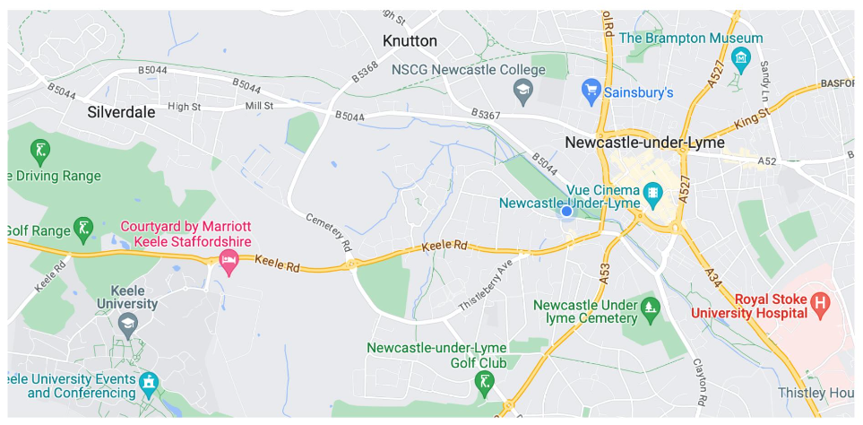
This area includes, but is not limited to, the following frequently used venues:

- St Giles’ Church
- St George’s Church
- Newcastle-under-Lyme town centre
- Newcastle Jubilee Sports Centre
- Streets near the school
- Cooper Croft Care Home
- Royal Stoke University Hospital
- Venues and Schools part of Three Spires Trust
- Keele University Sports Centre
- Newcastle Community High School
- NSCG

‘No-go’ areas within the Boundaries

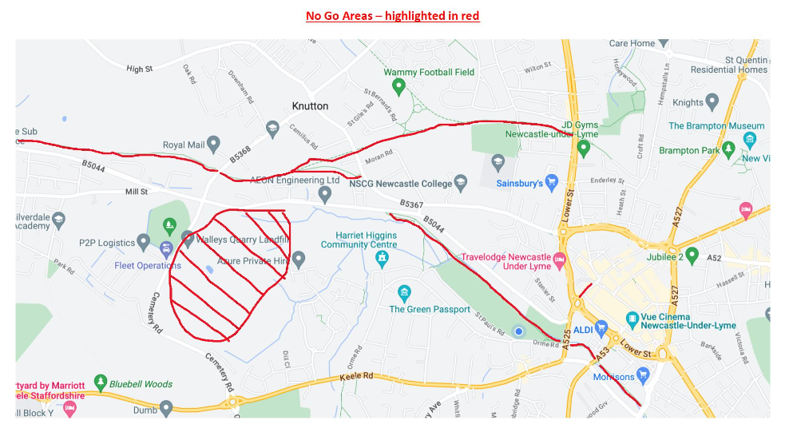

Transport to the Local Learning Area
The methods of transport used by the school will be wholly in the control of the school, such as the school minibus, walking or cycling. If using an outside provider please revert to the full visit form.

Operating Procedure

The following are potentially significant issues/hazards within our Local Learning Area:
- Road traffic.
- Other people / members of the public / animals.
- Losing a pupil.
- Uneven surfaces and slips, trips, and falls.
- Weather conditions.
- Activity specific issues when doing fieldwork (nettles, brambles, rubbish, etc).
- Pupil behaviour

These are managed by a combination of the following:

- The Head, Deputy or SLT member must give verbal approval before a group leaves.
- Only staff judged competent to supervise groups in this environment are approved. A current list of approved staff is maintained by the EVC and office.
- The concept and Operating Procedure of the ‘Local Learning Area’ is explained to all new parents when their child joins the school, and a synopsis is in the School Prospectus.
- There will normally be a minimum of two adults. Staff ratios will be determined by the dynamics of the group leaving the school ground. A member of SLT or experienced staff member will be available to go to the group in the event of issues arises. Staff leading the group will take a phone with them so they can contact the school office or nominated staff member. With sports fixtures….
- Staff are familiar with the area, including any ‘no-go’ areas, and have practiced appropriate group management techniques.
- Pupils have been trained and have practiced standard techniques for road crossings in a group.
- Where appropriate, pupils are fully briefed on what to do if they become separated from the group.
- All remotely supervised work in the Local Learning Area is done in ‘buddy’ pairs as a minimum.
- Pupils’ clothing and footwear is checked for appropriateness prior to leaving school.
- Staff are aware of any relevant pupil medical information and ensure that any required medication is available.
- Staff will record the activity on EVOLVE (Local Area Visit module). (They will leave a completed ‘Signing out’ sheet with the office if there is any issues completing the form on evolve. This will be reported to the EVC and Head)
- A mobile is taken with each group and the office have a note of the number.
- Appropriate personal protective equipment is taken when needed (eg gloves,)
- When walking towards Newcastle town centre, pupils will be led by the edge of Queen Elizabeth II park towards Pool Dam road. They will cross at the crossing before Silverdale road. Children will use the underpass to cross into Newcastle town centre. Children will follow the road round to the right and cross the one-way street towards Newcastle town centre near Black’s menswear and walk through the alleyway towards Chatwins
- When walking towards St George’s church, pupils will be led through Newcastle along Merrial Street. They will use the underpass at the end of the road and take the pupils up the hill towards the church.
- When visiting the church, check the toilets are not being used by members of the community first.

First Aid Policy for LLA

The school First Aid Policy will be followed. A member of staff from school will be available to go and support the pupils if necessary. Any first aid incidents will be reported to parents in the normal way.

Monitoring and Evaluation

Staffordshire ensures that there is sample monitoring of the visits and LOtC activities undertaken by its establishments, either by attaching such monitoring duties to its officers, or by delegating these tasks to establishments. Such monitoring should be in keeping with the recommendations of NG. There is a clear expectation that the monitoring function is a delegated task, principally carried out through systems put in place by the establishment EVC.

At St Giles’ and St George’s C of E Academy, the EVC will carry out trip monitoring sporadically throughout the year. This will include a combination of a mini monitoring (monitoring the briefing of adults and children, a phone call check, a review conversation), or a full monitoring check (EVC attends the trip to monitor). This is to ensure that the staff adhere to this policy and have carried out what is stipulated on the risk assessment.

At St Giles’ and St George’s C of E Academy, we evaluate our trips to ensure that they are appropriate and met the intended aims. We aim to enrich the curriculum and evaluating out visits ensures that we are planning appropriate ways to do this. The trip leader is required to fill in the Evaluation Form on Evolve within 1 week of the trip taking place. Where a trip has not met intended outcomes SLT will be notified and careful consideration can be made if the trip were to be requested in future.

Policy Review

This policy will be reviewed by the Educational Visits Coordinator in conjunction with the Headteacher and the governors in September 2026.

Links with other policies

This policy links with the following policies and procedures:
- Health and safety policy
- Behaviour policy
- Child protection policy
- First aid policy
- Supporting pupils with medical conditions policy
- Special educational needs (SEN) policy
- Equality information and objectives
- Accessibility plan
- Early Years Foundation Stage (EYFS) policy


Appendix 1-Educational Visits – Booking Form

Section One: To be completed by teacher and signed off by SLT before booking is made by the office.
Lead teacher: ____________________________________ Class: ____________
Visit to: ______________________________________________________________
Any additional workshops required? __________________________________________
Reason for visit/ links to learning: ___________________________________________
_____________________________________________________________________
Have you rang and checked learning outcomes? ____________________
Have you done a pre visit? If yes when? _________________________
If no, is one arranged and when for? ____________________________
Number of additional adults required and names: ________________________________
____________________________________________________________________
____________________________________________________________________
Date of trip: _________________________ Back up date: _______________________
Cost of trip so far (Without transport) _______________________________________
Agreed by SLT – Yes/ No Signed:_______________________ Date: ___________
Section Two: To be completed by office then cost agreed by SLT before final booking is made.
Please ring for transport quotes:
 | Name of company | Transport cost
Quote 1
Quote 2
Quote 3 (if required)

Total cost of trip - venue + (workshop) + transport = ___________________
Agreed by SLT – Yes/ No Signed:_______________________ Date: _____________

When total cost has been agreed then Paige is to book the Venue, (workshops) and transport please.
When everything is booked, it is the class teachers responsibility to send the letter to parents and complete the risk assessment. Letter minimum of 3 weeks notice – longer is possible. Risk assessment should be completed no later than 2 weeks before the visit.
Paige will set the trip up on Parent Pay the same day the letter sent. Please communicate to ensure they are done on the same day.

Appendix 2: risk assessment templates/examples (editable versions on TEAMS)
Generic
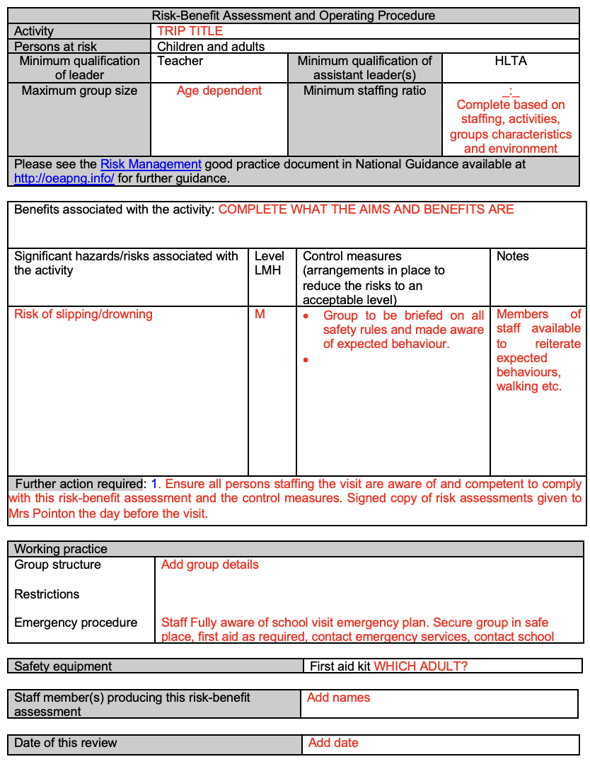

Coach Travel
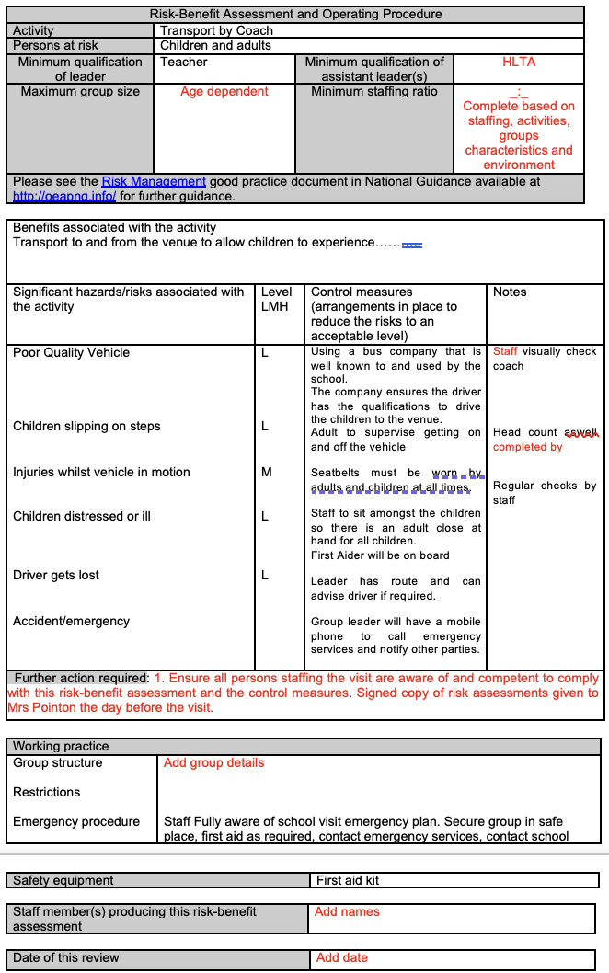
Minibus Risk Assessment
Vulnerable Children Risk Assessment 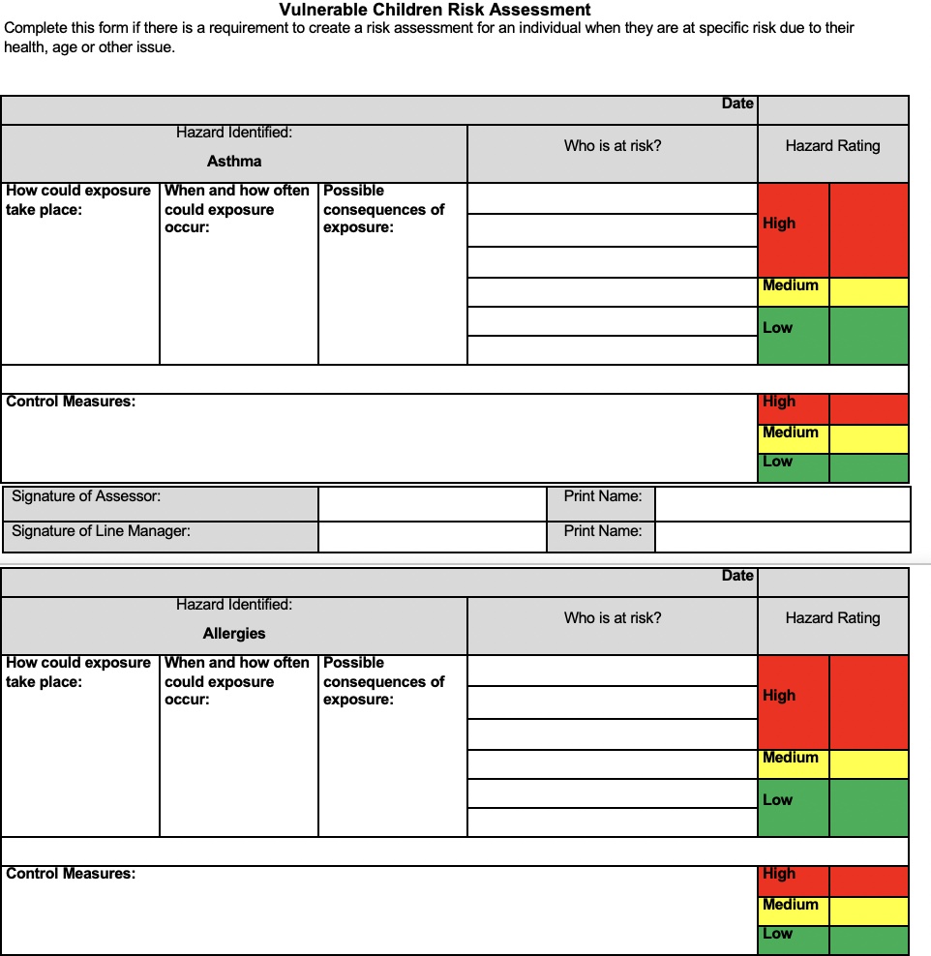

Appendix 3: volunteer behaviour and code of conduct

Parent helper Guidelines for educational visits out of school:

Thank you for volunteering to support learning outside the school environment it not only supports learning in a hands on practical way but energises and motivates children to be curious, excited learners. There are

Please could you read the following before committing to the visit out of school as there are a number of recommendations we have to have in place in order to keep all children and adults safe.

- It is the opportunity to see children learning in a different environment;
- We will offer support and encouragement to ensure you are prepared for the day;
- Follow advice from teachers;
- Read and sign the risk assessment before leaving school;
- Encourage children to engage with the learning environment and the guide ( if there is one);
- Please interact with all children in the group by asking questions or answering children’s questions;
- Parent volunteers are responsible for all their small group of children not just their child, so no special favours please (eg: sweets on coach);
- Help children manage their packed lunches ( age appropriate);
- Permanent staff members take children to toilets;
- At no time are you to be alone with any children.
- No mobile phones can be taken on the trip;
- Maintain confidentiality (eg: social media web sites);

Once parents have read this form, they must print and sign their name, along with the time and date.

Signed ____________________________________ Date:______________________

Appendix 4: template letter for parents/carers and consent form

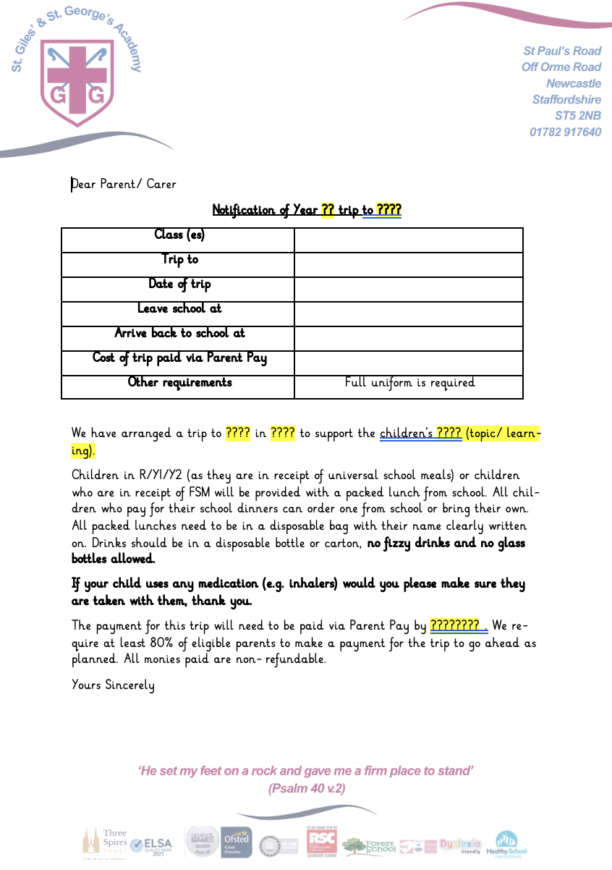
checklist for educational visits:
suggested order
Tick when completed
Search trip pricing (researching trips linked to intentions)
Booking form completed and sent to SLT
Date and staffing passed by head teacher and added to school calendar
Coach quote and arrangements organised by office
Insurance arranged – covered by off-site journey insurance
Booking form confirmation sent back to trip leader
Parents notified of letter, sent to office and copies added to website. (2 months before due to payments)
Parental Consent Forms completed and returned (including medication forms where needed)
If needed complete a risk assessment visit to venue
Risk assessments written (at least 2 weeks before 4 weeks for residentials)
Including emergency contact arrangements and staff member responsible for medication.
Evolve (online) Form completed and passed by EVC. Any additional risk assessments, along with risk assessments for specific individuals, attached to Evolve form. (at least 2 weeks before 4 weeks for residentials)
This form passed to EVC for approval and notes might be sent back (check emails)
EVC will then pass form on to Headteacher
All monies received to be paid into Bursar (collected through parent pay/Arbor)
When approved, print evolve and attachments and get all staff/adults to sign
Day before/On the day:
Medication collected in and recorded
Charge iPad for trip photographs
Collect First Aid equipment and trip first aid book from office
Collect student data sheets from office (care plans etc).
Ensure you have a mobile phone and that the number is the one on the risk assessment
Collect cheque / card / float (if applicable)
Brief all staff
Printed evolve and attachments to be on Headteachers desk before leaving the building
School Office contacted to inform of any issues arising or/and late return to school
On return:
Complete the visit evaluation form on evolve (1 week)
EVC to check phones to ensure no photographs of children
Appendix 5: educational visits checklist

