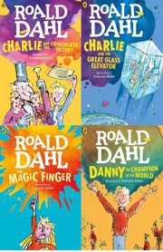
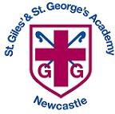
Year 1/2 Spring 2 Curriculum Overview
English
Text: The Lighthouse Keeper’s Lunch
Skills:
- Expanded noun phrases
- Imperative verbs
- Sentence types
- Commas for a list
- Embedding skills focused on in the previous half term.

Mathematics
Focus: Multiplication and Division
Objectives include:
- Recall and use multiplication facts for the 2, 5 and 10 times table.
- Show that multiplication of numbers can be done in any order (commutative) but that division can not.
- To write multiplication and division number sentences using the correct symbols.
- Solve problems using arrays, repeated addition and mental methods, including problems in contexts.
PSHE
Unit: Healthy Me
Overview:
- Healthy Choices
- Lifestyle
- Motivation

Religious Education
Unit: Christianity - God
Key Question: What do Christians believe God is like?
Author for this half term; Julia Donaldson
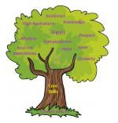
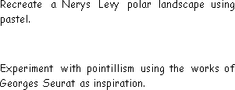
PE

Invasion Games
Master basic movements including
running, jumping, throwing and catching.
Gymnastics
Developing balance agility and
co -ordination.
Science
Unit: Living Things and their Habitats
Why do we care for plants and animals?
Key questions/ experiments:
What different habitats are there on planet
Earth and what lives in each habitat?

Unit: Programming – Scratch Junior
- To know that the character is controlled by programming blocks.
- To know that loops are created by repeating instructions.
Computing
Art/Design Technology

Unit: Cooking and Nutrition
What am I worth?
- Understand what makes a balanced diet.
- To know the five different food groups.
- To know that ingredients make up a recipe.
Music
Unit: Musical symbols
Read symbols representing high and low sounds.
Demonstrate an awareness of pitch, rhythm and dynamics.
Humanities
Unit: Great Explorers
Is it okay to try and give up?
Key Question:
How have explorers changed the world?

